PISHPEK
No information has been found for this period yet
42.88133, 74.61413

Фотография пока не добавлена
ENGLISH
No information has been found for this period yet.

FRUNZE
Kyrgyz State Circus
42.88133, 74.61413
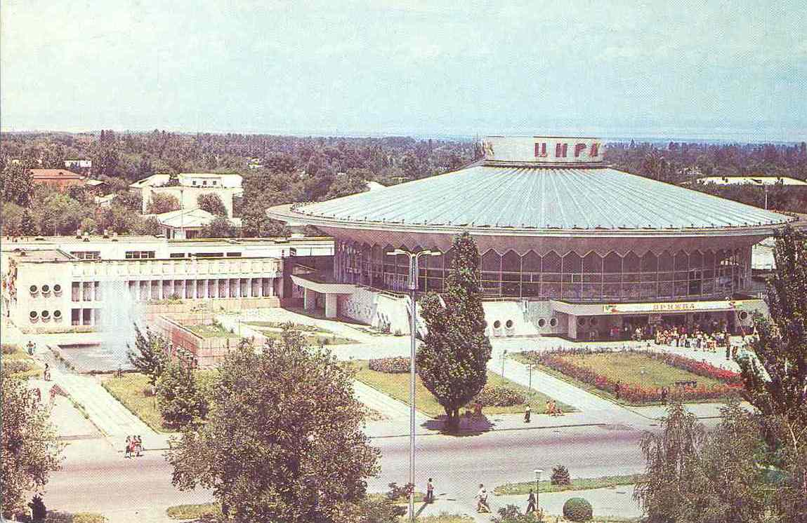
Киргизский госцирк · Штейнберга
ENGLISH Kyrgyz State Circus
﻿ Kyrgyz State Circus, 1984. Architects L. Segal, V. Shadrin, A. Nezhurin were awarded the Prize of the Council of Ministers of the USSR, 1976. The opening of the new building took place on November 11, 1977. Construction of a circus. During the construction of the circus, quite decent buildings were demolished to create a spatial perspective, such as the House of Public Services (on the left side of the photo). Photo from 1974. Fountains of the
Source: https://bimap.su/description/frunze/257_Zirk.txt · BIMAP
Фотографии и материалы принадлежат их авторам; лицензия не указана

BISHKEK
No information has been found for this period yet
42.88133, 74.61413

Фотография пока не добавлена
ENGLISH
No information has been found for this period yet.

