PISHPEK
No information has been found for this period yet
42.88190, 74.59928

Фотография пока не добавлена
ENGLISH
No information has been found for this period yet.

FRUNZE
Komsomol Factory
42.88190, 74.59928
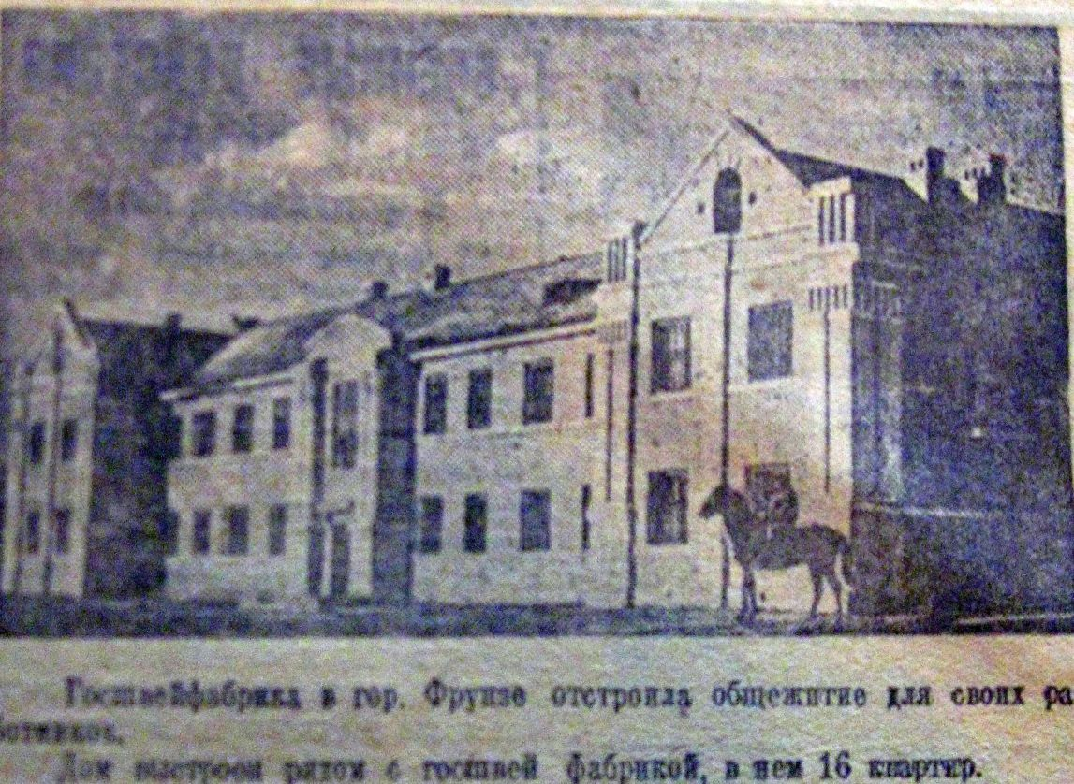
Фабрика ВЛКСМ
ENGLISH Komsomol Factory
﻿ Komsomol Factory. Photo from a 1937 newspaper. State Shveyfabrika dormitory, built in 1937. The sewing production association was created in 1976 on the basis of the state sewing factory No. 1, formed in 1933 from the sewing workshop of Gorpromtrest. It had dormitories, 2 kindergartens, and a club. The number of employees exceeded 1000 people.
Source: https://bimap.su/description/frunze/255_Gosshvei.txt · BIMAP
Фотографии и материалы принадлежат их авторам; лицензия не указана

BISHKEK
No information has been found for this period yet
42.88190, 74.59928

Фотография пока не добавлена
ENGLISH
No information has been found for this period yet.

