PISHPEK
No information has been found for this period yet
42.86104, 74.60799

Фотография пока не добавлена
ENGLISH
No information has been found for this period yet.

FRUNZE
Shanghai
42.86104, 74.60799
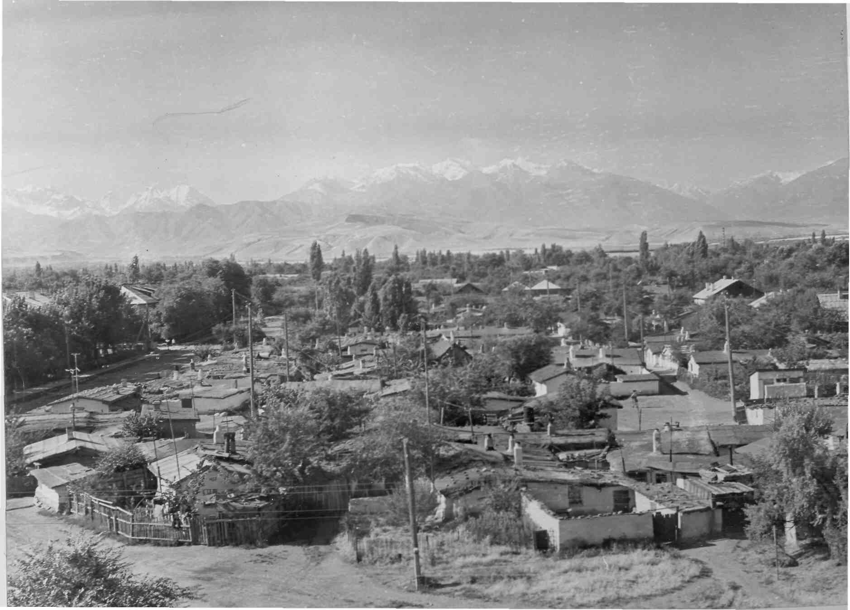
Шанхай
ENGLISH Shanghai
﻿ Shanghai During the years of devastation and war, refugees settled in such slums, building dugouts and huts for housing. “Shanghai”, “London” and “Paris” appeared in the city. One of these villages arose near the Frunze train station.
Source: https://bimap.su/description/frunze/245_Shanhai.txt · BIMAP
Фотографии и материалы принадлежат их авторам; лицензия не указана

BISHKEK
No information has been found for this period yet
42.86104, 74.60799

Фотография пока не добавлена
ENGLISH
No information has been found for this period yet.

