PISHPEK
House on the corner of Bazarnaya and Dunganskaya streets
42.87457, 74.61191
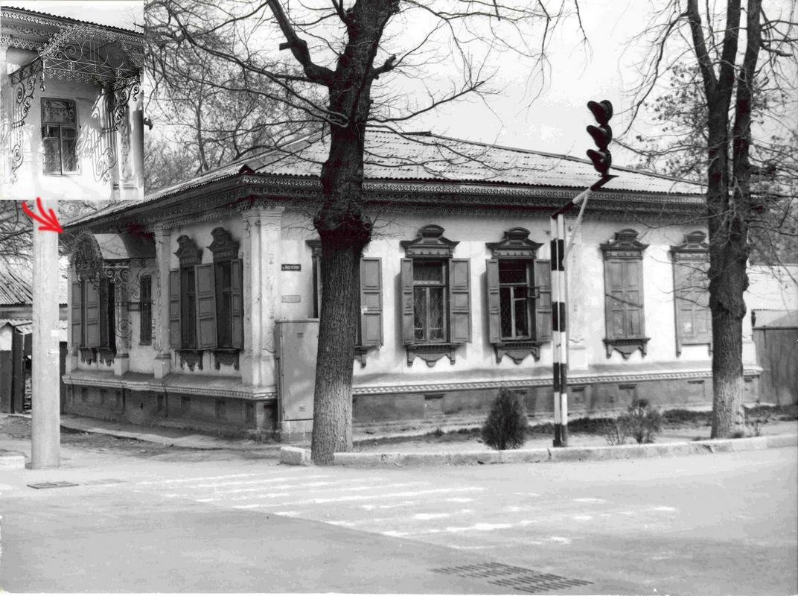
Дом на углу улиц Базарной и Дунганской
ENGLISH House on the corner of Bazarnaya and Dunganskaya streets
﻿ House on the north-eastern corner of Bazarnaya and Dunganskaya streets. Beginning of the twentieth century The construction of residential buildings in the city of Pishpek was carried out strictly according to plan. Rectilinear streets formed squares or rectangles of blocks and in one block there were four to six plots, each with an area of ​​0.1 hectares. Houses on courtyard estates were placed on the corner or in the center of the site, with
Source: https://bimap.su/description/pishpek/45_Bazarnaia_Dunganskaia.txt · BIMAP
Фотографии и материалы принадлежат их авторам; лицензия не указана

FRUNZE
No information has been found for this period yet
42.87457, 74.61191

Фотография пока не добавлена
ENGLISH
No information has been found for this period yet.

BISHKEK
No information has been found for this period yet
42.87457, 74.61191

Фотография пока не добавлена
ENGLISH
No information has been found for this period yet.

