PISHPEK
No information has been found for this period yet
42.88139, 74.61104

Фотография пока не добавлена
ENGLISH
No information has been found for this period yet.

FRUNZE
Library
42.88139, 74.61104
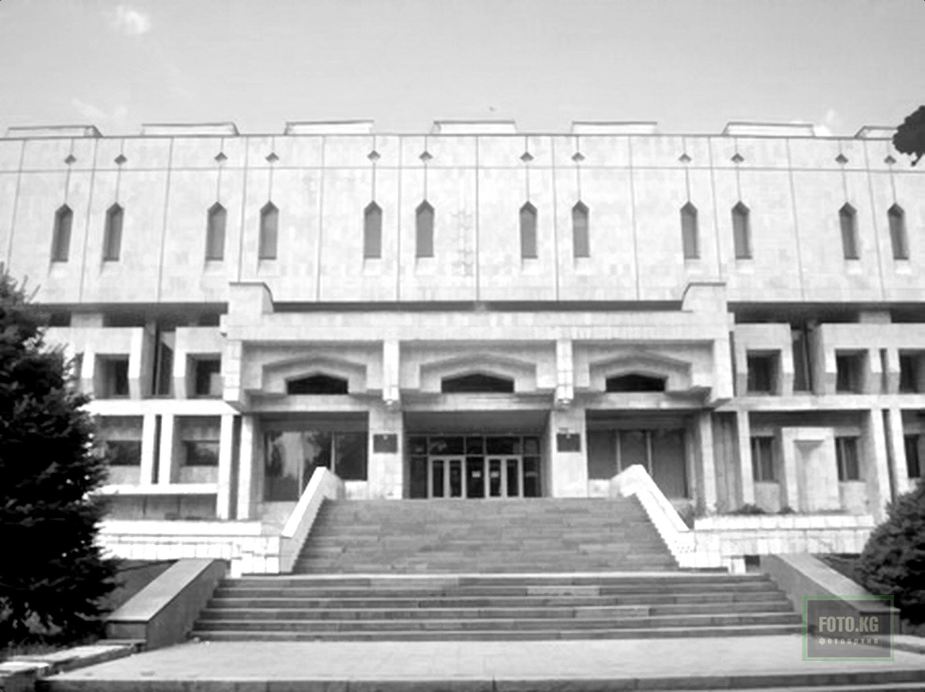
Библиотека
ENGLISH Library
﻿ State Library named after Lenin built in 1984 The building of the State Library named after Lenin was built in 1984. Architects N. Nurgaziev, K. Ibraev, R. Asylbekov. In 1993, the library was transformed into the National Library of the Kyrgyz Republic.
Source: https://bimap.su/description/frunze/243_Biblioteka.txt · BIMAP
Фотографии и материалы принадлежат их авторам; лицензия не указана

BISHKEK
No information has been found for this period yet
42.88139, 74.61104

Фотография пока не добавлена
ENGLISH
No information has been found for this period yet.

