PISHPEK
No information has been found for this period yet
42.86583, 74.59570

Фотография пока не добавлена
ENGLISH
No information has been found for this period yet.

FRUNZE
Surgical building
42.86583, 74.59570
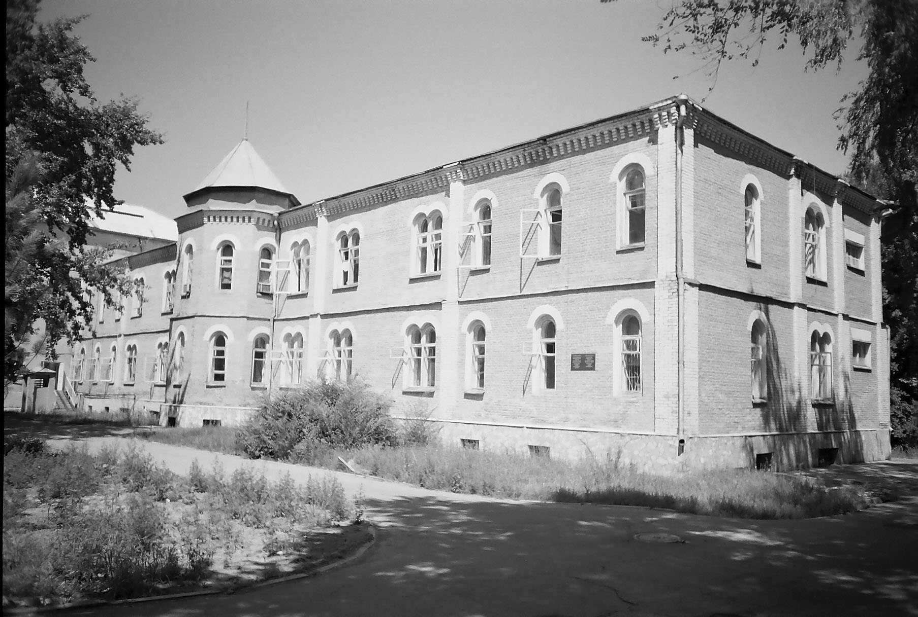
Хирургический корпус · Владимира Петрова
ENGLISH Surgical building
﻿ Surgical building of the Republican Hospital The building was built according to the design of the architect A. Zenkov in 1928. Only three of the five buildings built by Zenkov have survived to this day: the Assembly of the People of Kyrgyzstan, the surgical center of the national hospital, and the bank on Erkindyk Avenue. And today, among the modern buildings of the city, they stand out for their unusual appearance and decorate the city. A.P.
Source: https://bimap.su/description/frunze/241_Hirurgia.txt · BIMAP
Фотографии и материалы принадлежат их авторам; лицензия не указана

BISHKEK
No information has been found for this period yet
42.86583, 74.59570

Фотография пока не добавлена
ENGLISH
No information has been found for this period yet.

