PISHPEK
No information has been found for this period yet
42.87682, 74.58784

Фотография пока не добавлена
ENGLISH
No information has been found for this period yet.

FRUNZE
Sculptural composition "Manas"
42.87682, 74.58784
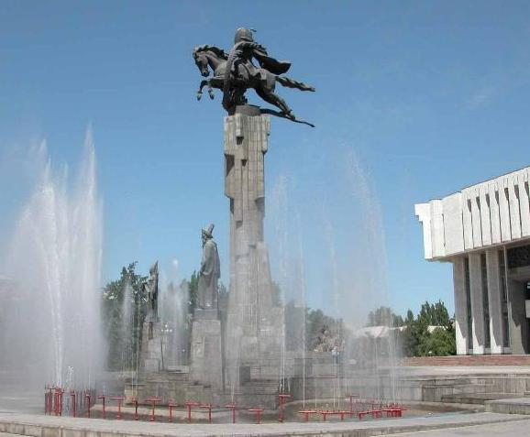
Скульптурная композиция «Манас»
ENGLISH Sculptural composition "Manas"
﻿ Sculptural composition "Manas" Sculptural composition "Manas". Installed in 1981 in front of the entrance to the Philharmonic and dedicated to the main characters of the Kyrgyz epic of the same name. The center of the composition is the figure of Manas killing the dragon. The height of the sculpture is 6.3 m, the length of the dragon is 13 m, the height of the pedestal, lined with gray granite, is 14.7 m. Below the central figure, on its edges
Source: https://bimap.su/description/frunze/238_Manas.txt · BIMAP
Фотографии и материалы принадлежат их авторам; лицензия не указана

BISHKEK
Architectural and sculptural composition "Manas"
42.87682, 74.58784
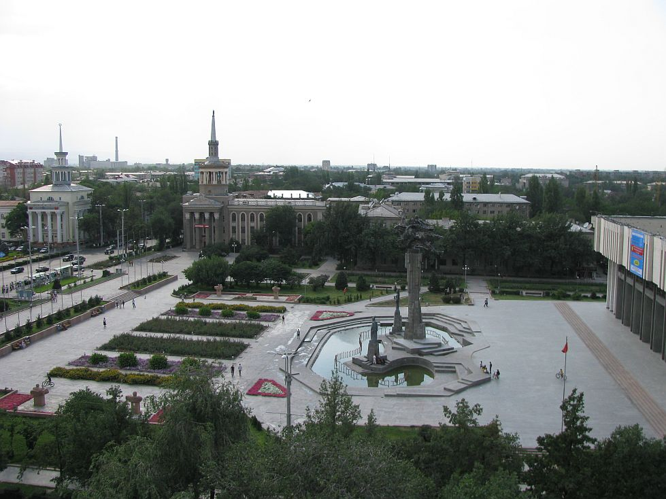
Архитектурно-скульптурная композиция Манас · Евгения Коровина
ENGLISH Architectural and sculptural composition "Manas"
Architectural and sculptural composition "Manas" in front of the Philharmonic building Architectural and sculptural composition "Manas" in front of the Philharmonic building.
Source: https://bimap.su/description/bishkek/38_IMG_0370.txt · BIMAP
Фотографии и материалы принадлежат их авторам; лицензия не указана

