PISHPEK
No information has been found for this period yet
42.87734, 74.58660

Фотография пока не добавлена
ENGLISH
No information has been found for this period yet.

FRUNZE
“Alley of Youth”
42.87734, 74.58660
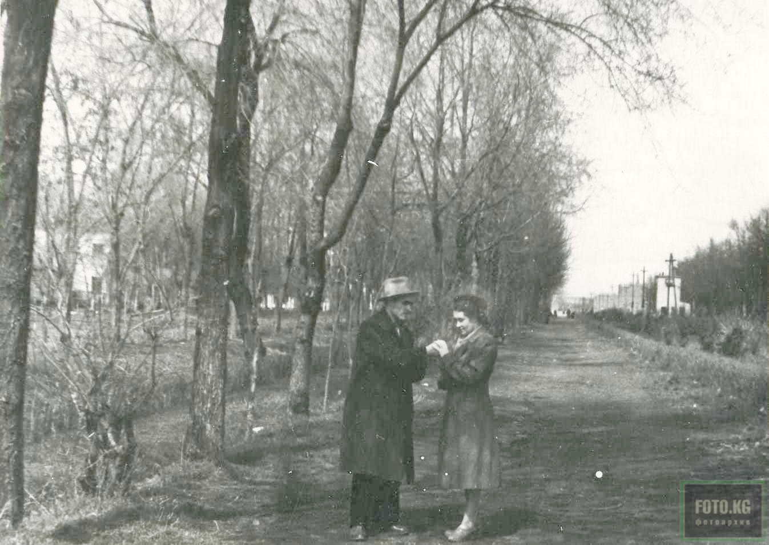
«Аллея молодежи» · 50-х
ENGLISH “Alley of Youth”
﻿ Alley of Youth, photo of the 50s from A. Marusich’s album This street then bore the name Krupskaya. And it looked more like an alley lined with trees and bushes than today’s Alley of Youth, encased in paving stones and bare. Initially the street was called Barachnaya, then Krupskaya, and later Tabyshalieva.
Source: https://bimap.su/description/frunze/231_Alleia.txt · BIMAP
Фотографии и материалы принадлежат их авторам; лицензия не указана

BISHKEK
Youth Alley
42.87734, 74.58660
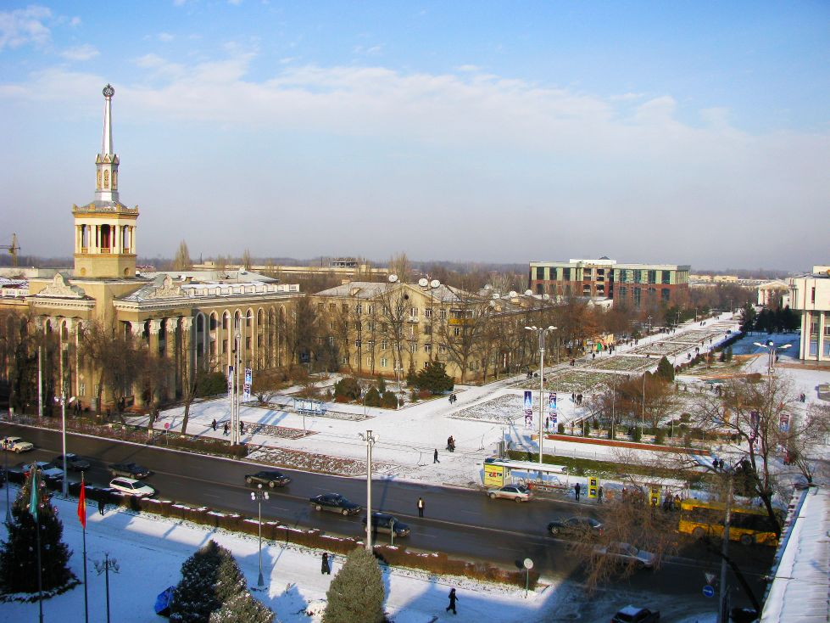
Аллея молодежи · Евгения Коровина
ENGLISH Youth Alley
Winter Youth Alley Winter Youth Alley.
Source: https://bimap.su/description/bishkek/126_IMG_1321.txt · BIMAP
Фотографии и материалы принадлежат их авторам; лицензия не указана

