PISHPEK
No information has been found for this period yet
42.87986, 74.58688

Фотография пока не добавлена
ENGLISH
No information has been found for this period yet.

FRUNZE
Monument to Shabdan Batyr
42.87986, 74.58688
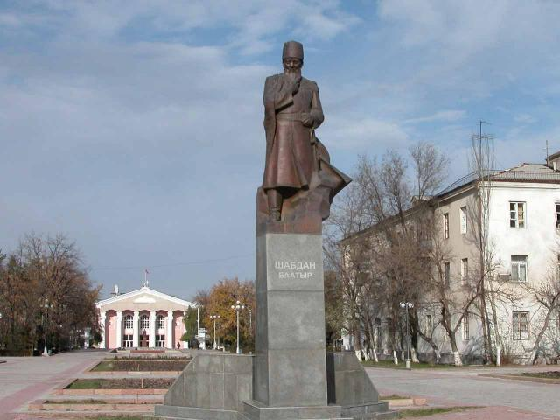
Памятник Шабдан Батыру
ENGLISH Monument to Shabdan Batyr
﻿ Monument to Shabdan Batyr Monument to Shabdan Batyr, installed in 1980. on the Alley of Youth.
Source: https://bimap.su/description/frunze/230_Shabdan.txt · BIMAP
Фотографии и материалы принадлежат их авторам; лицензия не указана

BISHKEK
No information has been found for this period yet
42.87986, 74.58688

Фотография пока не добавлена
ENGLISH
No information has been found for this period yet.

