PISHPEK
No information has been found for this period yet
42.87559, 74.60193

Фотография пока не добавлена
ENGLISH
No information has been found for this period yet.

FRUNZE
Knitting factory
42.87559, 74.60193
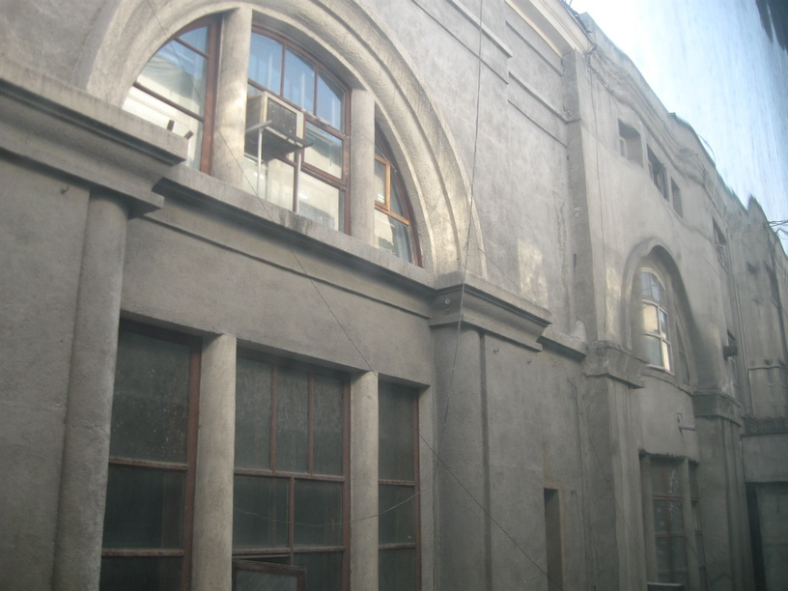
Трикотажная фабрика · Владимира Петрова
ENGLISH Knitting factory
﻿ Knitting factory Knitting factory named after Mikoyan. The building was built for the largest department store in the city. In 1941, it housed a knitting factory evacuated from Kharkov, on the basis of which the Ilbirs knitting association was created in 1971.
Source: https://bimap.su/description/frunze/220_Fabrika.txt · BIMAP
Фотографии и материалы принадлежат их авторам; лицензия не указана

BISHKEK
No information has been found for this period yet
42.87559, 74.60193

Фотография пока не добавлена
ENGLISH
No information has been found for this period yet.

