PISHPEK
No information has been found for this period yet
42.88372, 74.59955

Фотография пока не добавлена
ENGLISH
No information has been found for this period yet.

FRUNZE
Lenin Street
42.88372, 74.59955
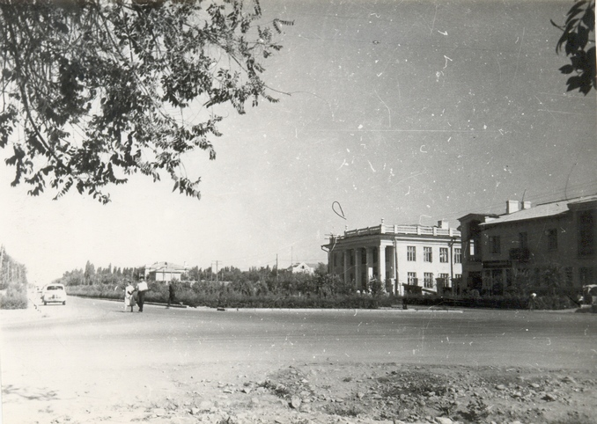
Улица Ленина
ENGLISH Lenin Street
﻿ Lenin Street (Zhibek Zholu), 1955 The Tashkent highway, crossing the entire city from west to east, receives the name Tashkent Street in the city of Frunze. Since August 1938, Tashkentskaya was renamed Lenin Street, and in 1960 it became Lenin Avenue. In October of the anniversary year 1974. Lenin Avenue was renamed to Avenue. 50th anniversary of the Kirghiz SSR.
Source: https://bimap.su/description/frunze/218_UlLenina.txt · BIMAP
Фотографии и материалы принадлежат их авторам; лицензия не указана

BISHKEK
No information has been found for this period yet
42.88372, 74.59955

Фотография пока не добавлена
ENGLISH
No information has been found for this period yet.

