PISHPEK
No information has been found for this period yet
42.88413, 74.59736

Фотография пока не добавлена
ENGLISH
No information has been found for this period yet.

FRUNZE
Resurrection Cathedral
42.88413, 74.59736
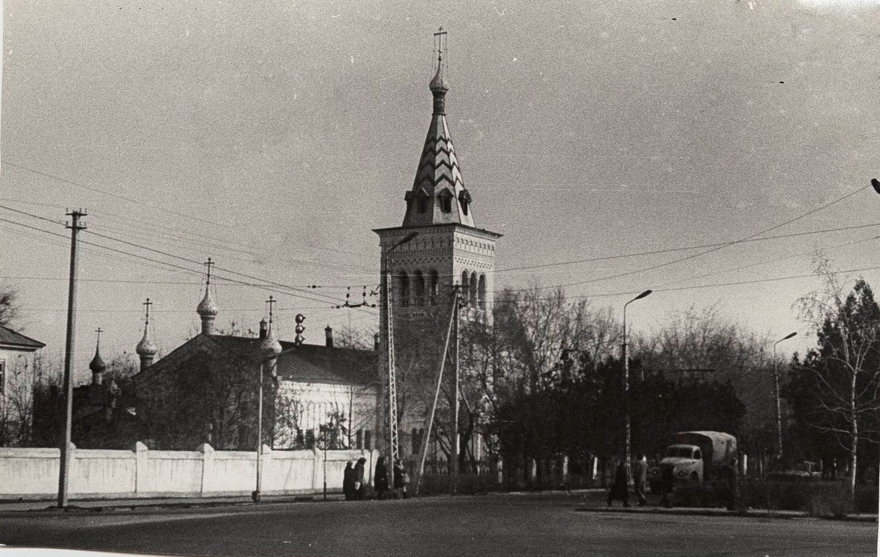
Воскресенский собор
ENGLISH Resurrection Cathedral
﻿ Resurrection Cathedral, 50s In 1944, the Orthodox community in the city of Frunze was offered an unfinished workers' club building. The reconstruction was carried out according to the design of the architect V. Veryuzhsky. The building was decorated with six small domes on high narrow drums and a tented bell tower 29.5 m high was erected.
Source: https://bimap.su/description/frunze/215_Zerkov.txt · BIMAP
Фотографии и материалы принадлежат их авторам; лицензия не указана

BISHKEK
Temple of the Resurrection
42.88413, 74.59736
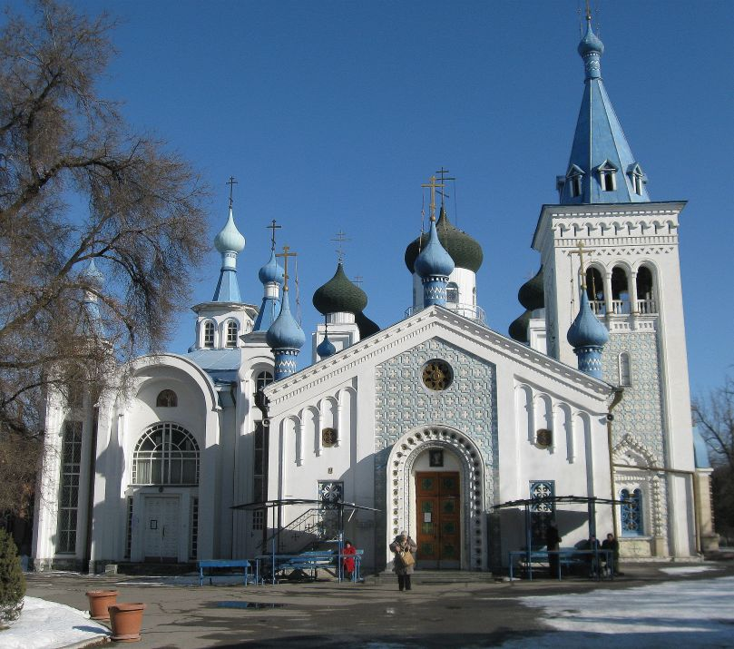
Храм Воскресения · Владимира Петрова
ENGLISH Temple of the Resurrection
Temple of the Resurrection.
Source: https://bimap.su/description/bishkek/140_Hram.txt · BIMAP
Фотографии и материалы принадлежат их авторам; лицензия не указана

