PISHPEK
No information has been found for this period yet
42.88338, 74.59648

Фотография пока не добавлена
ENGLISH
No information has been found for this period yet.

FRUNZE
Voroshilov Street
42.88338, 74.59648
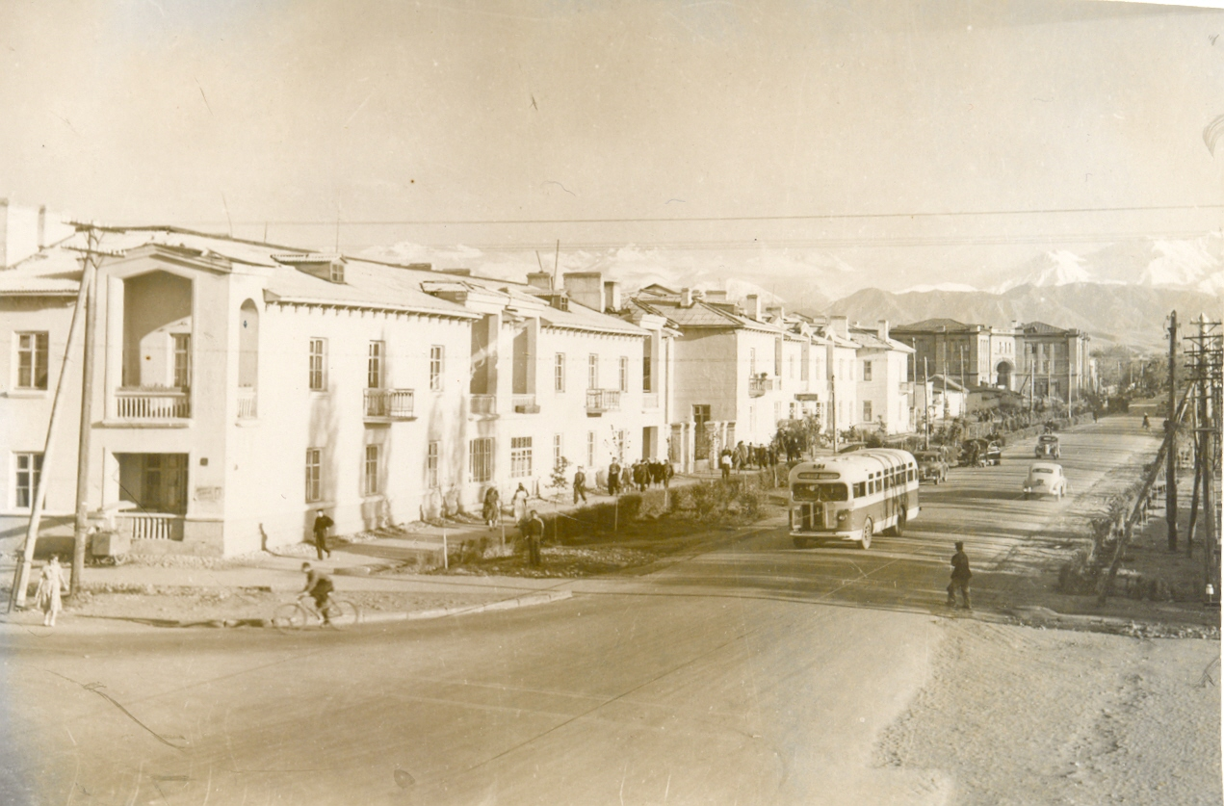
Улица Ворошилова
ENGLISH Voroshilov Street
﻿ Voroshilov Street (Togolok Moldo), 50s Initially, the street was called Barracks. Since 1938 to 1975 the street was named after Voroshilov. Then she became Athletic. In June 1960 to commemorate the 100th anniversary of the birth of the most prominent akyn Togolok Moldo (Baimbet Abdrakhmanov (1860-1942)), it became a street named after him.
Source: https://bimap.su/description/frunze/214_Voroshilova.txt · BIMAP
Фотографии и материалы принадлежат их авторам; лицензия не указана

BISHKEK
No information has been found for this period yet
42.88338, 74.59648

Фотография пока не добавлена
ENGLISH
No information has been found for this period yet.

