PISHPEK
Pashkov's House
42.87490, 74.60299
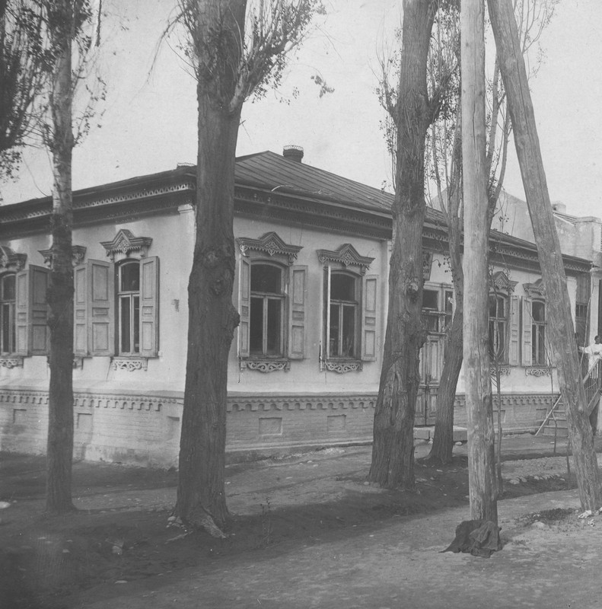
Дом Пашкова
ENGLISH Pashkov's House
﻿ Pashkov's House of the early twentieth century (Meshchanskaya-Dunganskaya) The construction of residential buildings in the city of Pishpek was carried out strictly according to plan. Rectilinear streets formed squares or rectangles of blocks and in one block there were four to six plots, each with an area of ​​0.1 hectares. Houses on courtyard estates were placed on the corner or in the center of the site, with the main facades facing the stre
Source: https://bimap.su/description/pishpek/42_Dom_Pashkova.txt · BIMAP
Фотографии и материалы принадлежат их авторам; лицензия не указана

FRUNZE
Building of the Research Institute of Epidemiology and Microbiology
42.87490, 74.60299
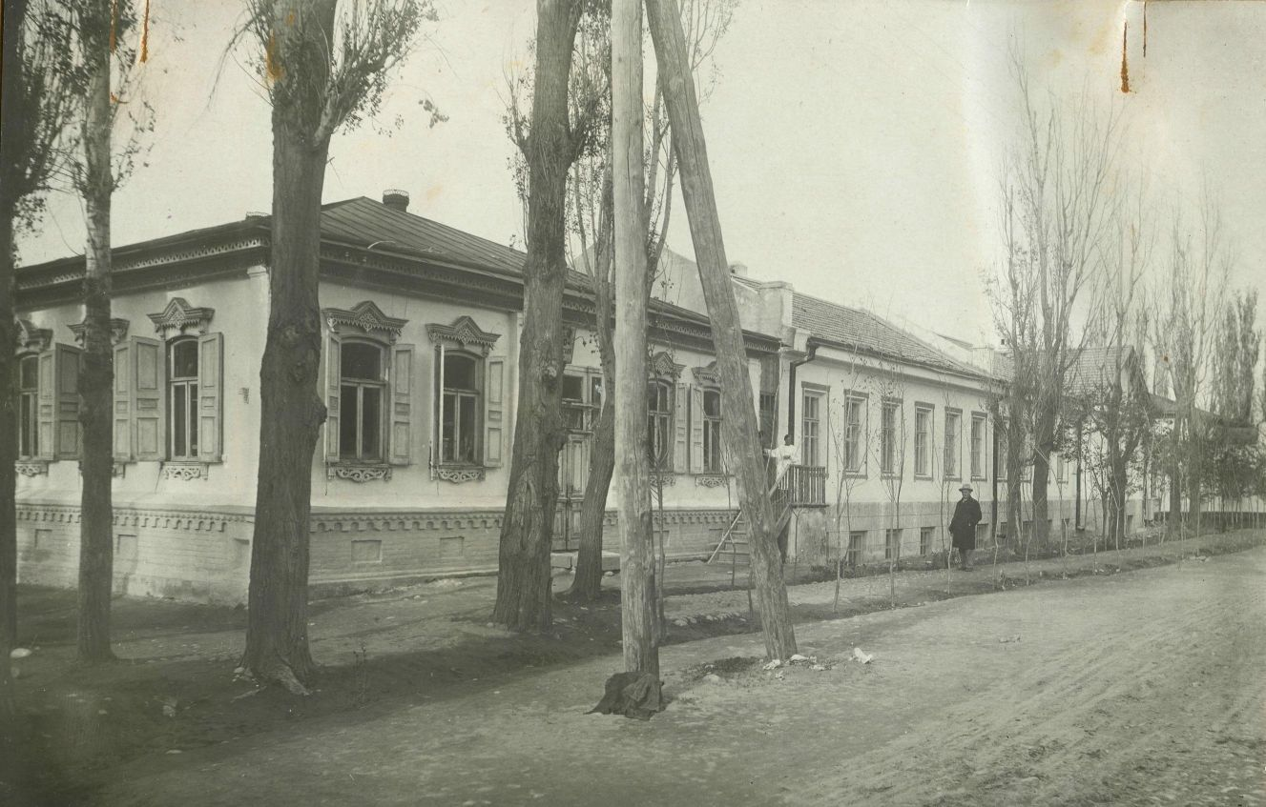
Здание НИИ эпидемиологии и микробиологии
ENGLISH Building of the Research Institute of Epidemiology and Microbiology
﻿ Building of the Research Institute of Epidemiology and Microbiology Created in 1927 as a Veterinary Laboratory and located in the house of the industrialist Pashkov, built in the early twentieth century. The house stood on a high stone foundation made of hewn stone, above which there was a semi-basement basement with patterned brickwork decor. The walls are made of hewn logs. The facade is plastered with carved cornices, platbands, and shutters
Source: https://bimap.su/description/frunze/117_Mikrobiologia.txt · BIMAP
Фотографии и материалы принадлежат их авторам; лицензия не указана

BISHKEK
No information has been found for this period yet
42.87490, 74.60299

Фотография пока не добавлена
ENGLISH
No information has been found for this period yet.

