PISHPEK
No information has been found for this period yet
42.87795, 74.60898

Фотография пока не добавлена
ENGLISH
No information has been found for this period yet.

FRUNZE
Theater in Oak Park
42.87795, 74.60898
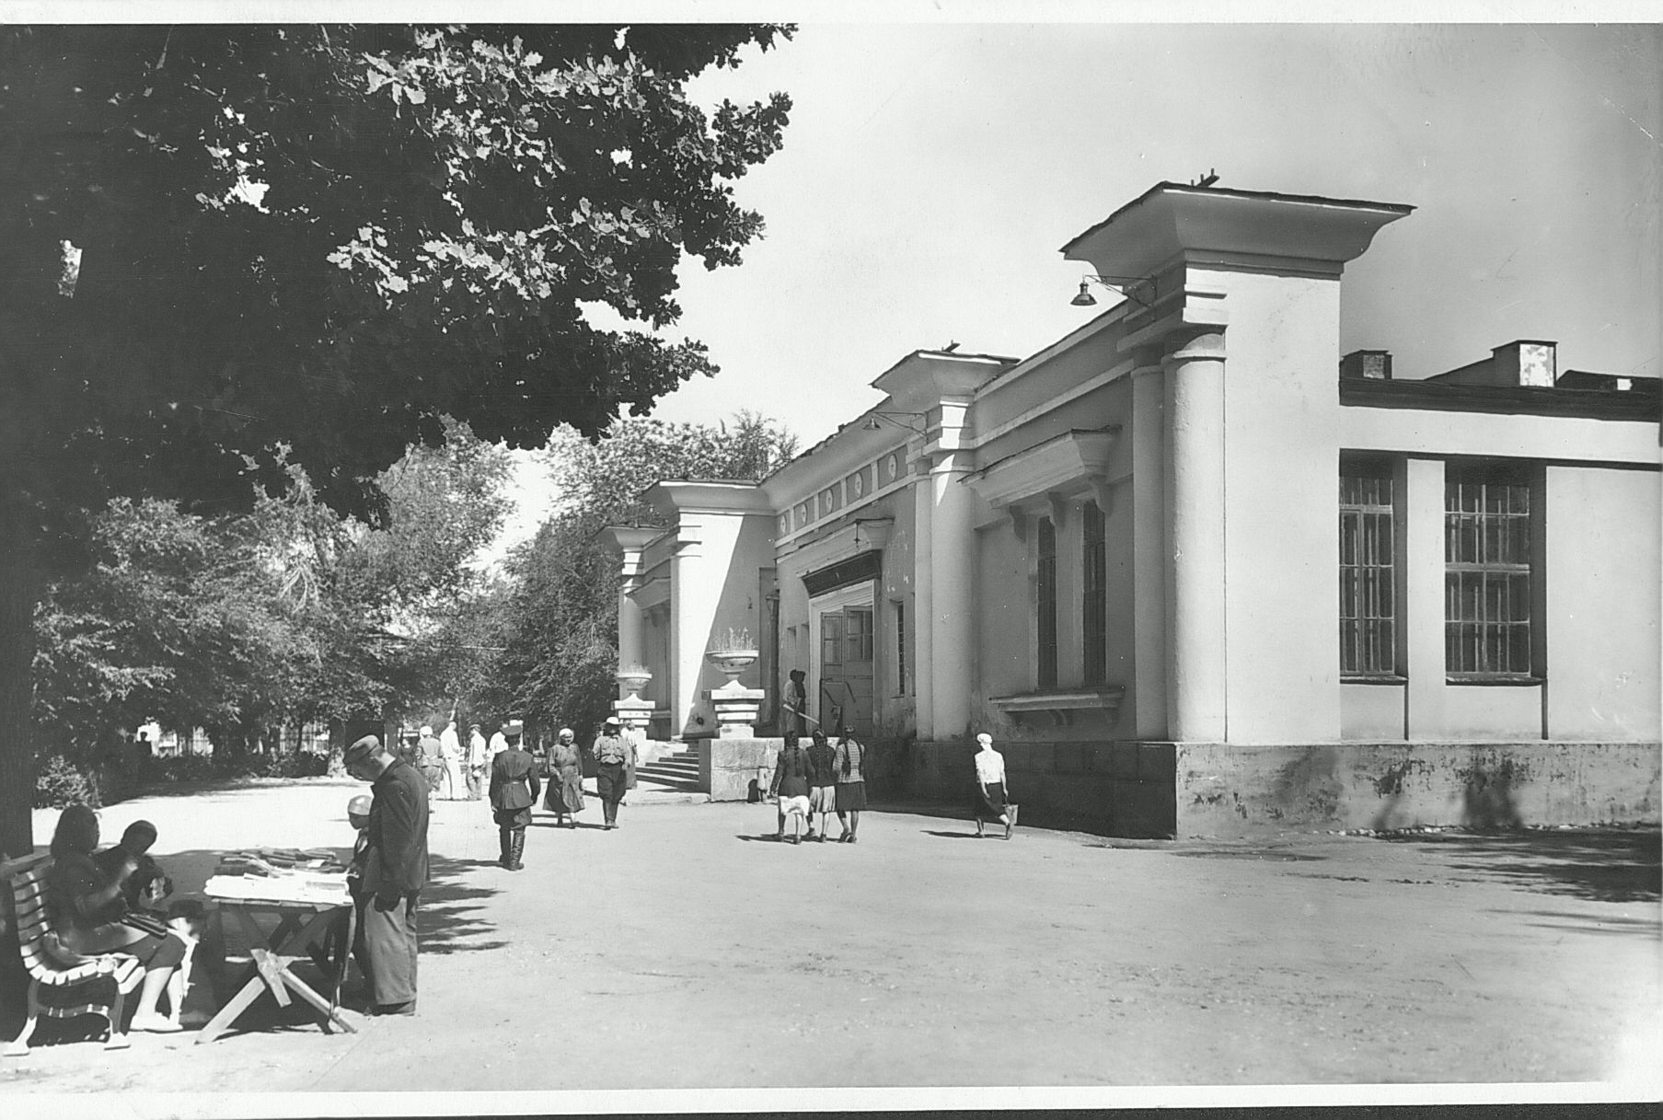
Театр в Дубовом парке
ENGLISH Theater in Oak Park
﻿ Theater in Oak Park The building of the Opera and Ballet Theater, 50s. The theater building was built on the site of the Edison cinema as a workers' club of Chustroy in 1928. Since 1935, the Kyrgyz Musical and Drama Theater and the Russian Drama Theater have been located here. In 1942, the building was reconstructed and housed the Kyrgyz State Opera and Ballet Theater, which operated in this building until 1955. Since 1955, the building has hou
Source: https://bimap.su/description/frunze/212_Teatr.txt · BIMAP
Фотографии и материалы принадлежат их авторам; лицензия не указана

BISHKEK
No information has been found for this period yet
42.87795, 74.60898

Фотография пока не добавлена
ENGLISH
No information has been found for this period yet.

