PISHPEK
No information has been found for this period yet
42.87400, 74.61438

Фотография пока не добавлена
ENGLISH
No information has been found for this period yet.

FRUNZE
Monument to Pushkin
42.87400, 74.61438
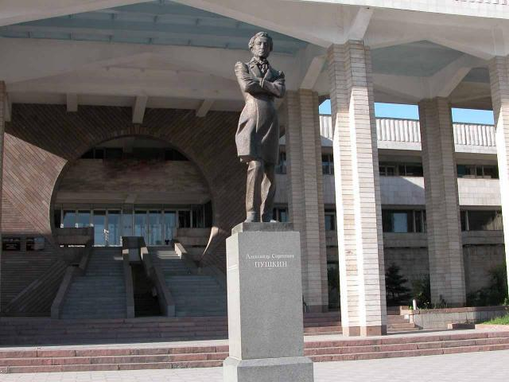
Памятник Пушкину
ENGLISH Monument to Pushkin
﻿ Monument to Pushkin Monument to Pushkin, sculptor V. Shestopal, architect R. Muksinov. Installed in 1999 in front of the building of the Kyrgyz-Russian Slavic University named after the first President of Russia B.N. Yeltsin. Inscription on the monument: Erected in honor of the 200th anniversary of the birth of the great poet on June 6, 1999. Cast at the Uralmash plant as a gift to Kyrgyzstan from the Sverdlovsk region.
Source: https://bimap.su/description/frunze/210_Pushkin.txt · BIMAP
Фотографии и материалы принадлежат их авторам; лицензия не указана

BISHKEK
No information has been found for this period yet
42.87400, 74.61438

Фотография пока не добавлена
ENGLISH
No information has been found for this period yet.

