PISHPEK
No information has been found for this period yet
42.87896, 74.60393

Фотография пока не добавлена
ENGLISH
No information has been found for this period yet.

FRUNZE
Monument to “Labor Glory”
42.87896, 74.60393
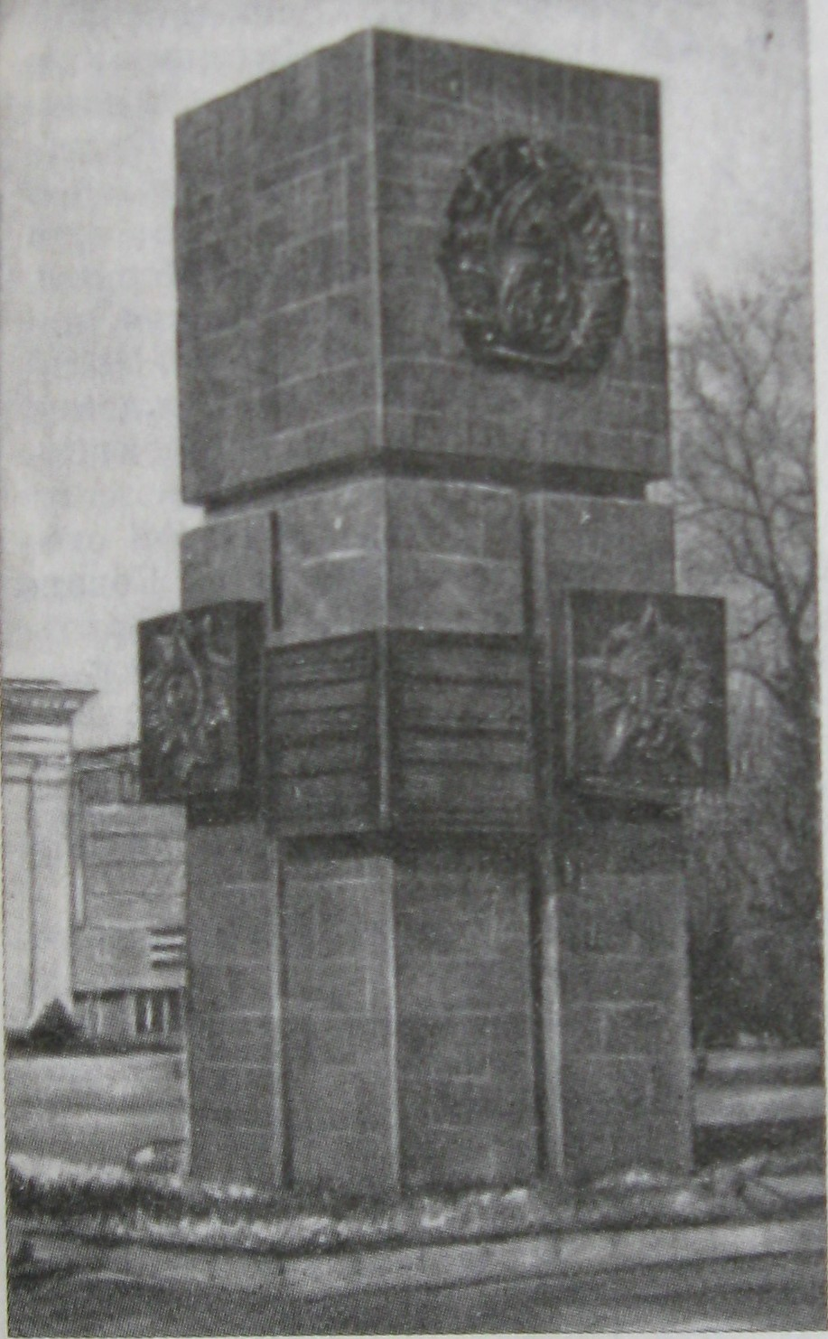
Памятник «Трудовой славы»
ENGLISH Monument to “Labor Glory”
﻿ Monument to Labor Glory The Monument to Labor Glory was erected in 1974 in honor of the fiftieth anniversary of the Kyrgyz SSR and the Communist Party of Kyrgyzstan. On the sides of the monument are the coat of arms of the Kirghiz SSR, two Orders of Lenin and the Order of Friendship of Peoples.
Source: https://bimap.su/description/frunze/209_Trud.txt · BIMAP
Фотографии и материалы принадлежат их авторам; лицензия не указана

BISHKEK
No information has been found for this period yet
42.87896, 74.60393

Фотография пока не добавлена
ENGLISH
No information has been found for this period yet.

