PISHPEK
No information has been found for this period yet
42.87081, 74.60547

Фотография пока не добавлена
ENGLISH
No information has been found for this period yet.

FRUNZE
Monument to Kainazarova
42.87081, 74.60547
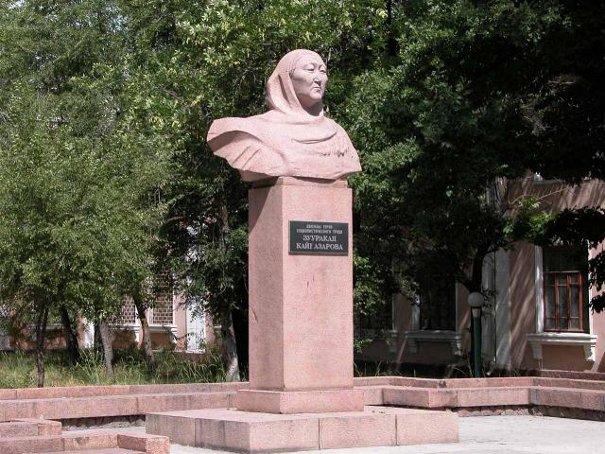
Памятник Кайназаровой
ENGLISH Monument to Kainazarova
﻿ Monument to Kainazarova, installed in 1975. Kainazarova, installed in 1975. Sculptor B.K. Sydykov. Kaynazarova Zuurakan (1972-1982). Twice Hero of Socialist Labor, innovator of collective farm production, beet grower, leader of the Druzhba collective farm in the Sokuluk district.
Source: https://bimap.su/description/frunze/208_Kainazarova.txt · BIMAP
Фотографии и материалы принадлежат их авторам; лицензия не указана

BISHKEK
No information has been found for this period yet
42.87081, 74.60547

Фотография пока не добавлена
ENGLISH
No information has been found for this period yet.

