PISHPEK
No information has been found for this period yet
42.87741, 74.57575

Фотография пока не добавлена
ENGLISH
No information has been found for this period yet.

FRUNZE
Monument to Komsomol Heroes
42.87741, 74.57575
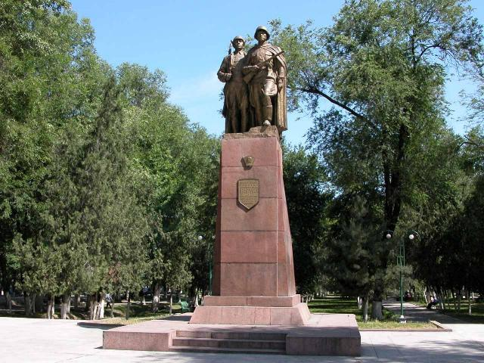
Памятник Героям-комсомольцам
ENGLISH Monument to Komsomol Heroes
﻿ Monument to Komsomol Heroes Monument to Komsomol Heroes of the 20s and 40s. Installed in 1963, sculptors V. Puzyrevsky and G. Tupykh.
Source: https://bimap.su/description/frunze/207_Geroi_komsom.txt · BIMAP
Фотографии и материалы принадлежат их авторам; лицензия не указана

BISHKEK
No information has been found for this period yet
42.87741, 74.57575

Фотография пока не добавлена
ENGLISH
No information has been found for this period yet.

