PISHPEK
No information has been found for this period yet
42.87717, 74.60546

Фотография пока не добавлена
ENGLISH
No information has been found for this period yet.

FRUNZE
Alley of the founding fathers
42.87717, 74.60546
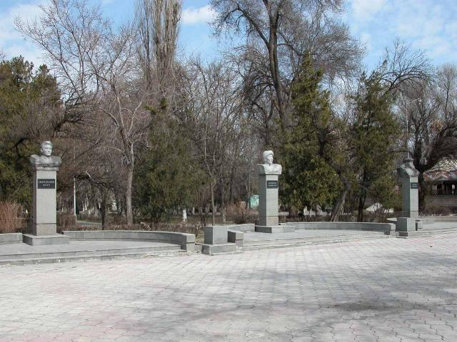
Аллеея отцов–основателей
ENGLISH Alley of the founding fathers
﻿ Alley Alley of the founding fathers of the statehood of Kyrgyzstan. 1996
Source: https://bimap.su/description/frunze/205_Alleia.txt · BIMAP
Фотографии и материалы принадлежат их авторам; лицензия не указана

BISHKEK
No information has been found for this period yet
42.87717, 74.60546

Фотография пока не добавлена
ENGLISH
No information has been found for this period yet.

