PISHPEK
House of industrialist Ivanov
42.87729, 74.60429
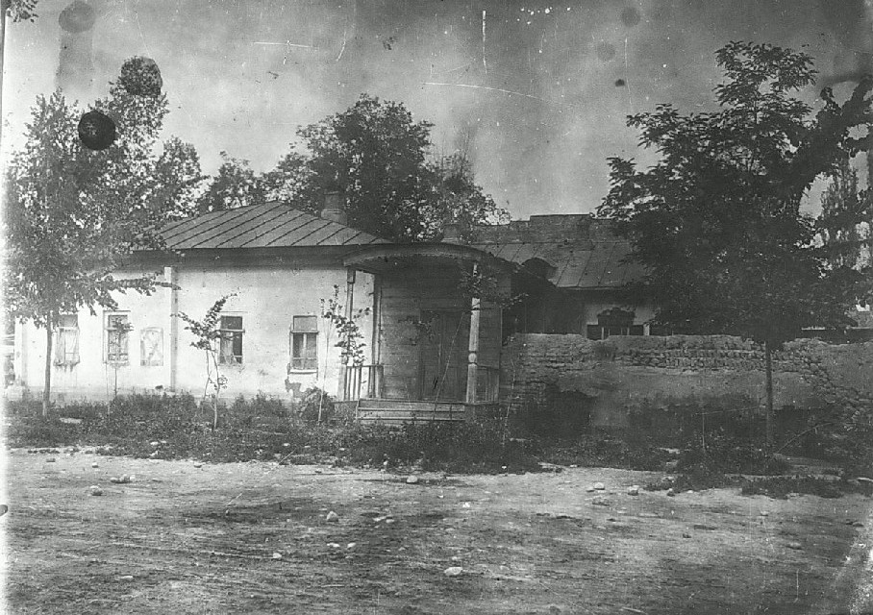
Дом промышленника Иванова
ENGLISH House of industrialist Ivanov
﻿ House of industrialist Ivanov on the northwestern corner of Vasilyevskaya and Tatarskaya streets. Beginning of the twentieth century. The construction of residential buildings in the city of Pishpek was carried out strictly according to plan. Rectilinear streets formed squares or rectangles of blocks and in one block there were four to six plots, each with an area of ​​0.1 hectares. Houses on courtyard estates were placed on the corner or in th
Source: https://bimap.su/description/pishpek/41_Dom_Ivanova.txt · BIMAP
Фотографии и материалы принадлежат их авторам; лицензия не указана

FRUNZE
No information has been found for this period yet
42.87729, 74.60429

Фотография пока не добавлена
ENGLISH
No information has been found for this period yet.

BISHKEK
No information has been found for this period yet
42.87729, 74.60429

Фотография пока не добавлена
ENGLISH
No information has been found for this period yet.

