PISHPEK
No information has been found for this period yet
42.87719, 74.60656

Фотография пока не добавлена
ENGLISH
No information has been found for this period yet.

FRUNZE
"Erkindik"
42.87719, 74.60656
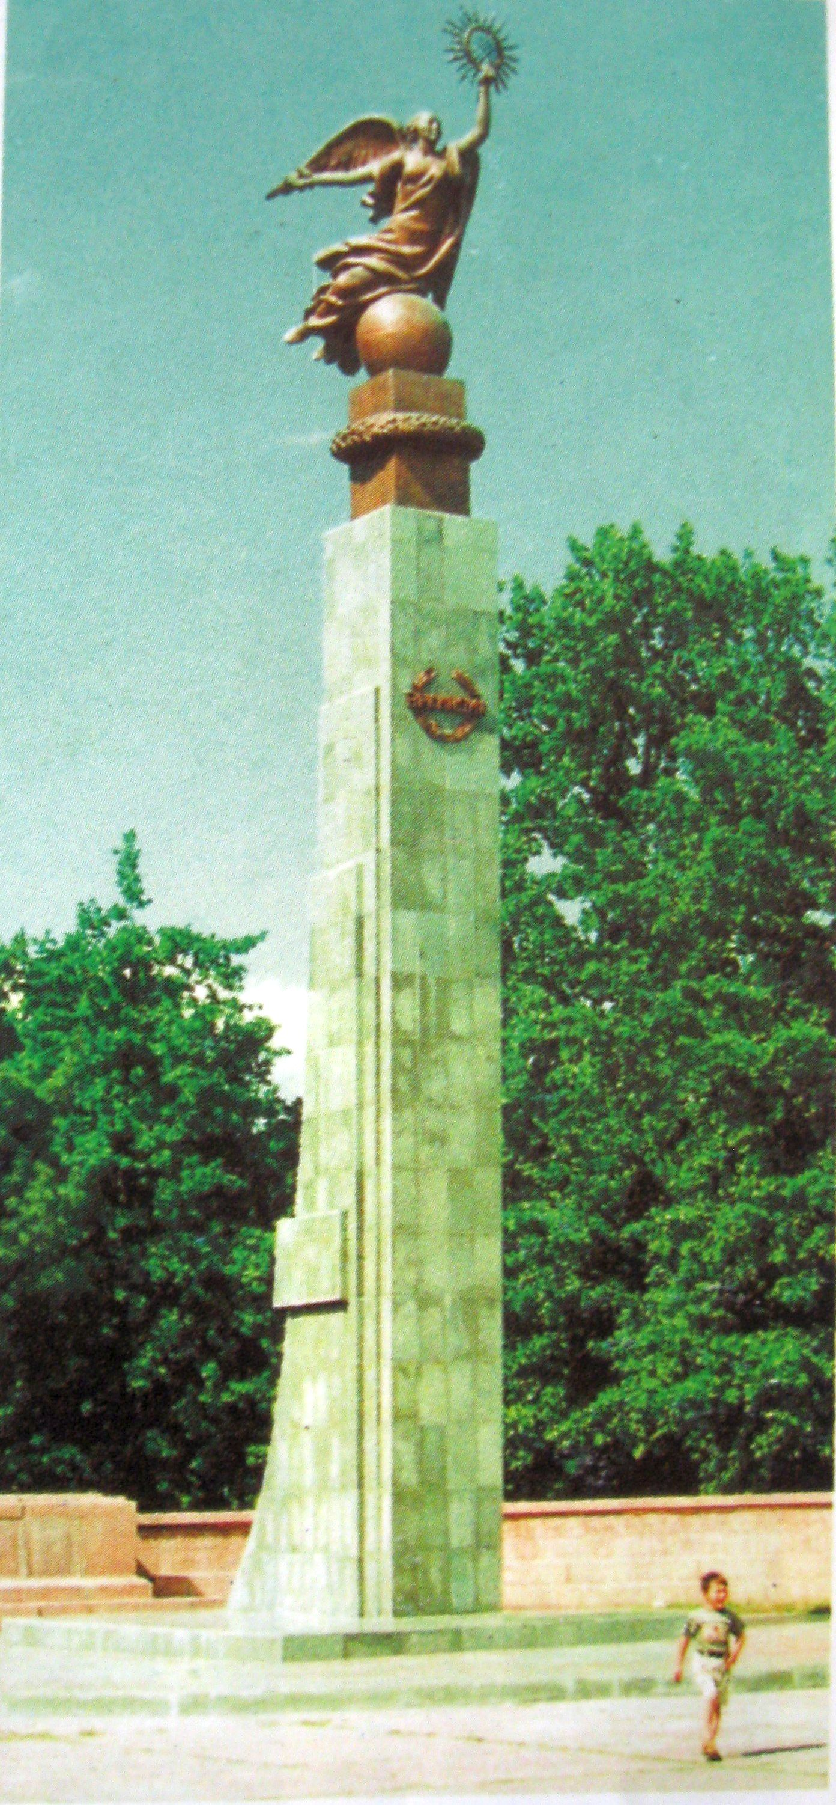
«Эркиндик»
ENGLISH "Erkindik"
﻿ Erkindik Erkindik - Statue of Liberty. Sculptor T. Sadykov. The monument was erected in 1999, to commemorate the 8th anniversary of the independence of Kyrgyzstan, on the site of the monument to Dzerzhinsky. In 2003, the Erkindik monument was dismantled and sent to the city of Batken, the birthplace of the sculptor Turgunbai Sadykov, and a new, larger copy was installed on the main square of the Capital of Kyrgyzstan.
Source: https://bimap.su/description/frunze/201_Erkindik.txt · BIMAP
Фотографии и материалы принадлежат их авторам; лицензия не указана

BISHKEK
No information has been found for this period yet
42.87719, 74.60656

Фотография пока не добавлена
ENGLISH
No information has been found for this period yet.

