PISHPEK
No information has been found for this period yet
42.87456, 74.60058

Фотография пока не добавлена
ENGLISH
No information has been found for this period yet.

FRUNZE
Republican military registration and enlistment office
42.87456, 74.60058
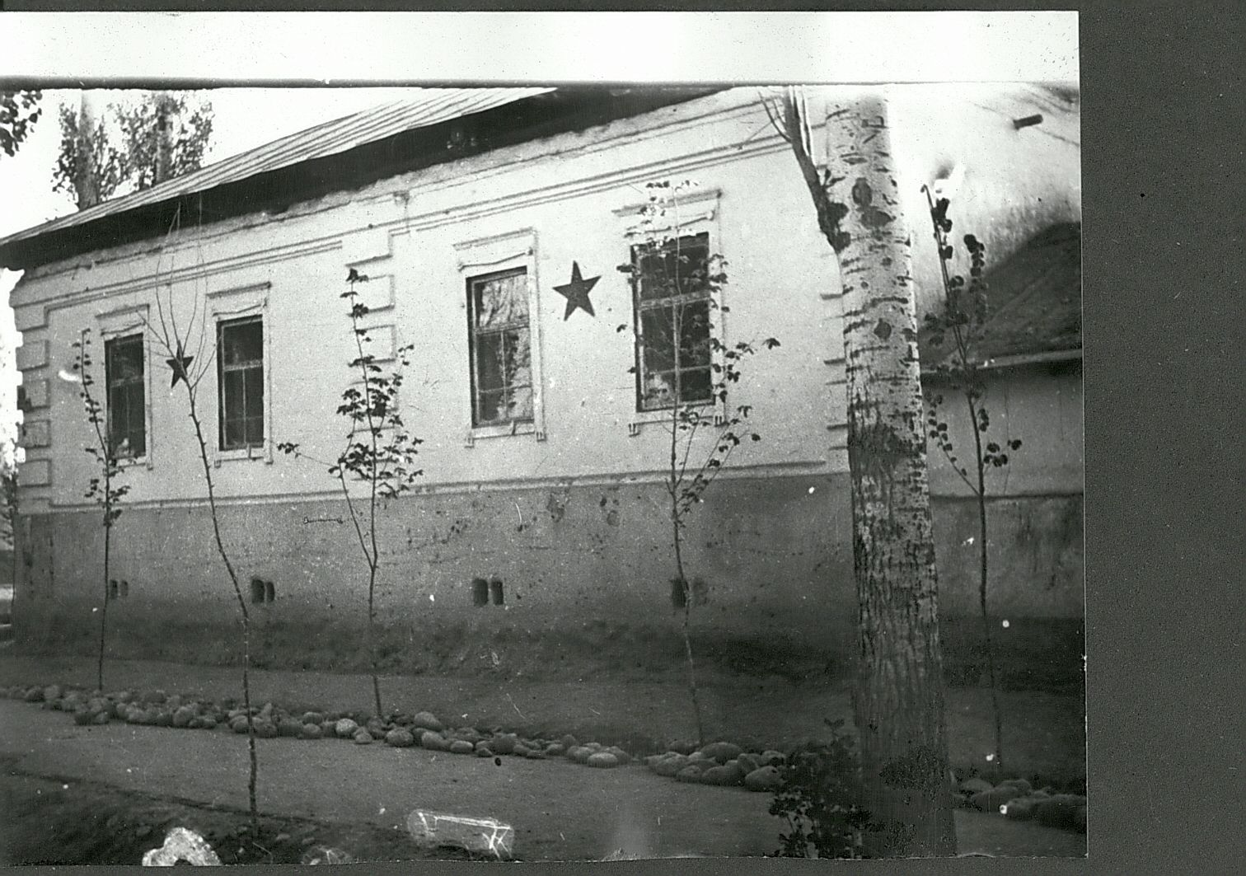
Республиканский военкомат
ENGLISH Republican military registration and enlistment office
﻿ Republican military registration and enlistment office, 40s Republican military registration and enlistment office, 40s. Before the war, I.V. Panfilov worked as a military commissar in this building.
Source: https://bimap.su/description/frunze/185_Voenkomat.txt · BIMAP
Фотографии и материалы принадлежат их авторам; лицензия не указана

BISHKEK
No information has been found for this period yet
42.87456, 74.60058

Фотография пока не добавлена
ENGLISH
No information has been found for this period yet.

