PISHPEK
No information has been found for this period yet
42.87684, 74.60819

Фотография пока не добавлена
ENGLISH
No information has been found for this period yet.

FRUNZE
Editorial office of “Literary Kyrgyzstan”
42.87684, 74.60819
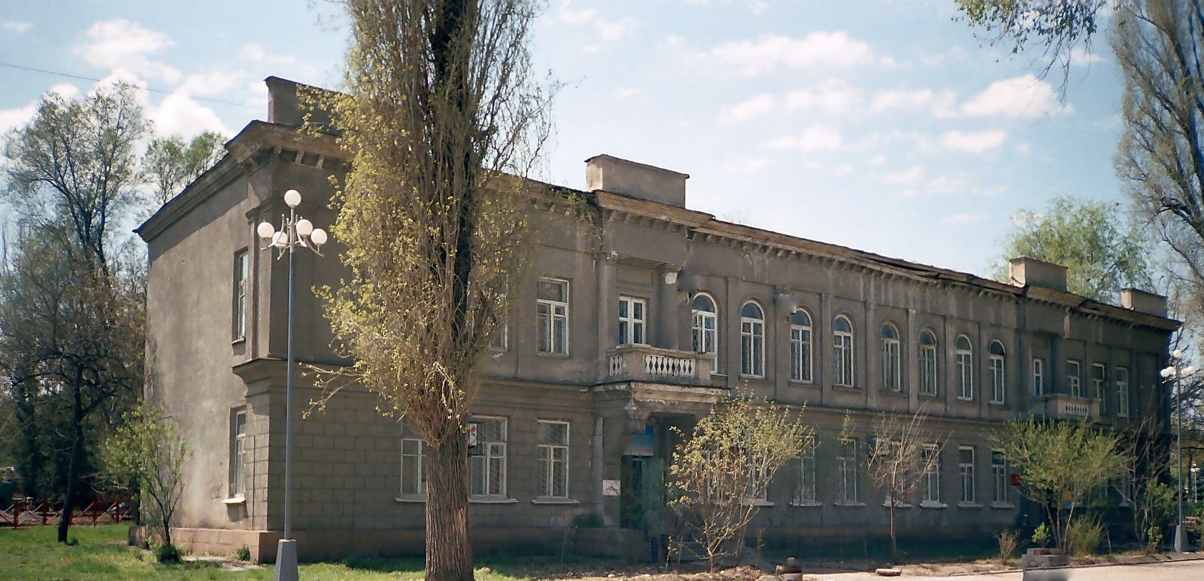
Редакция «Литературного Кыргызстана»
ENGLISH Editorial office of “Literary Kyrgyzstan”
﻿ Editorial office of Literary Kyrgyzstan The building was built in 1940, architect Steblin. Until 1986, it housed the Writers' Union of Kyrgyzstan, then the editorial offices of Kyrgyzstan Madaniyata and Literary Kyrgyzstan.
Source: https://bimap.su/description/frunze/184_Redaksia.txt · BIMAP
Фотографии и материалы принадлежат их авторам; лицензия не указана

BISHKEK
No information has been found for this period yet
42.87684, 74.60819

Фотография пока не добавлена
ENGLISH
No information has been found for this period yet.

