PISHPEK
No information has been found for this period yet
42.87173, 74.60386

Фотография пока не добавлена
ENGLISH
No information has been found for this period yet.

FRUNZE
Administrative building
42.87173, 74.60386
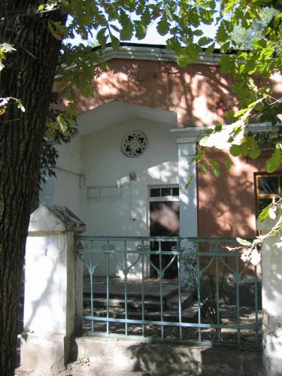
Административное здание · 2007 года
ENGLISH Administrative building
﻿ Administrative building Administrative building. Photo from 2007, built in the 50s.
Source: https://bimap.su/description/frunze/183_Pervomaiskaia.txt · BIMAP
Фотографии и материалы принадлежат их авторам; лицензия не указана

BISHKEK
No information has been found for this period yet
42.87173, 74.60386

Фотография пока не добавлена
ENGLISH
No information has been found for this period yet.

