PISHPEK
House and ancient gate
42.88360, 74.59185
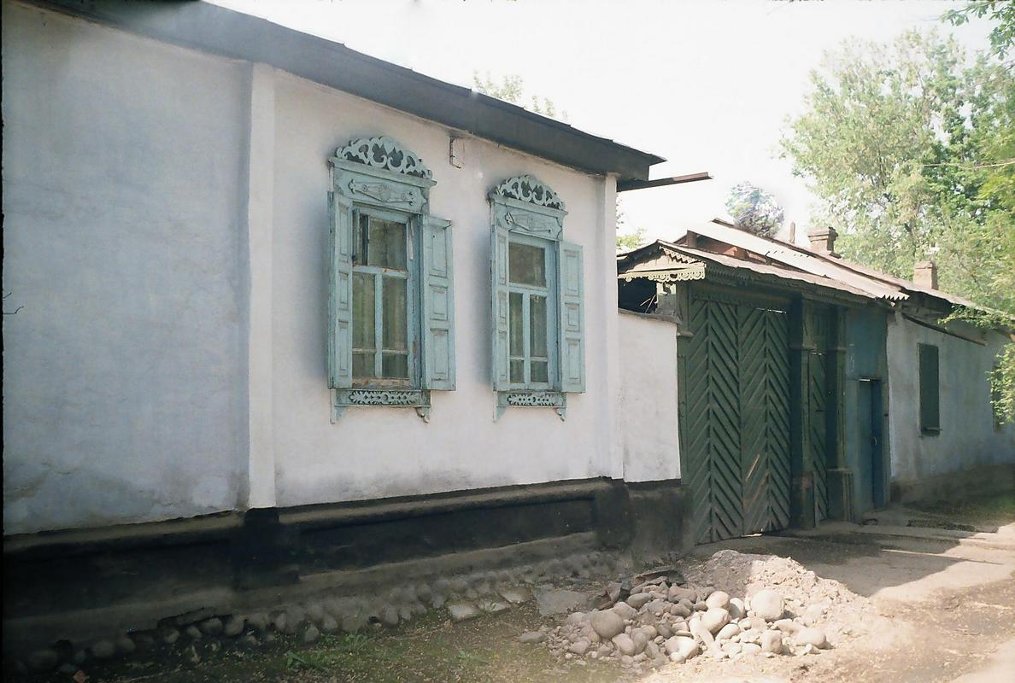
Дом и старинные ворота · Владимира Петрова
ENGLISH House and ancient gate
﻿ House and ancient gate on Tashkent street. The construction of residential buildings in the city of Pishpek was carried out strictly according to plan. Rectilinear streets formed squares or rectangles of blocks and in one block there were four to six plots, each with an area of ​​0.1 hectares. Houses on courtyard estates were placed on the corner or in the center of the site, with the main facades facing the street. Basically, the city consiste
Source: https://bimap.su/description/pishpek/38_Dom_i_vorota.txt · BIMAP
Фотографии и материалы принадлежат их авторам; лицензия не указана

FRUNZE
No information has been found for this period yet
42.88360, 74.59185

Фотография пока не добавлена
ENGLISH
No information has been found for this period yet.

BISHKEK
No information has been found for this period yet
42.88360, 74.59185

Фотография пока не добавлена
ENGLISH
No information has been found for this period yet.

