PISHPEK
No information has been found for this period yet
42.87663, 74.60369

Фотография пока не добавлена
ENGLISH
No information has been found for this period yet.

FRUNZE
Lenin Square
42.87663, 74.60369
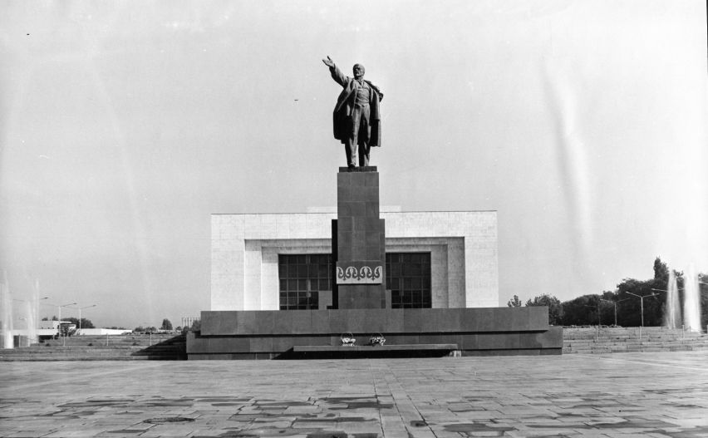
Площадь Ленина
ENGLISH Lenin Square
﻿ Lenin Square, 80s The square was created in 1984 during the construction of a branch of the Central Museum of V.I. Lenin and a monument to the leader (sculptors A. Kibalnikov, T. Sadykov, architects E. Kutyrev, A. Isaev). On November 7, 2003, the monument was dismantled and moved to the north side of the museum.
Source: https://bimap.su/description/frunze/173_Plojad_Lenina.txt · BIMAP
Фотографии и материалы принадлежат их авторам; лицензия не указана

BISHKEK
Monument to Manas
42.87663, 74.60369
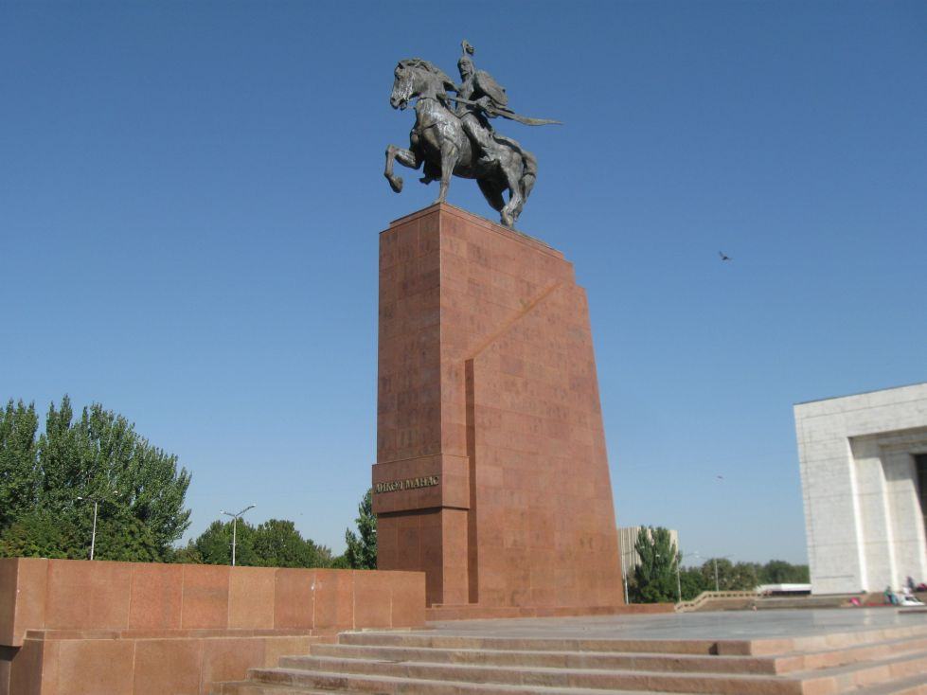
Памятник Манасу
ENGLISH Monument to Manas
On August 31, 2011, in honor of the 20th anniversary of the independence of Kyrgyzstan, a nine-meter bronze figure of the hero on horseback, called “Aikol Manas - Manas the Magnanimous,” rose on Ala-Too Square. Sculptor Bazarbai Sydykov. Photo by Vladimir Petrov. The bronze horseman has replaced the statue of "Erkindik" - Freedom - a winged woman on top of a globe holding a "tunduk" above her head, the round frame that forms the top of a traditio
Source: https://bimap.su/description/bishkek/3_manas.txt · BIMAP
Фотографии и материалы принадлежат их авторам; лицензия не указана

