PISHPEK
No information has been found for this period yet
42.87776, 74.59824

Фотография пока не добавлена
ENGLISH
No information has been found for this period yet.

FRUNZE
City panorama
42.87776, 74.59824
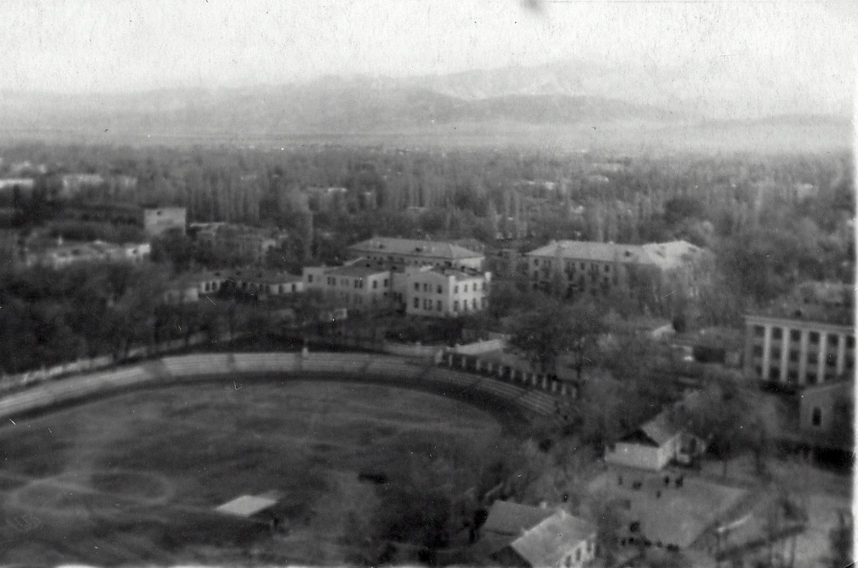
Панорама города · Владимира Петрова
ENGLISH City panorama
﻿ City panorama City panorama. Photo by Petrov, 1955. View from the parachute tower. In the foreground is the city stadium Labor Reserves. In the center is the House of Officers of the Soviet Army, to the left of it is the city military registration and enlistment office, to the right is the House of Trade Unions.
Source: https://bimap.su/description/frunze/171_Panorama55.txt · BIMAP
Фотографии и материалы принадлежат их авторам; лицензия не указана

BISHKEK
No information has been found for this period yet
42.87776, 74.59824

Фотография пока не добавлена
ENGLISH
No information has been found for this period yet.

