PISHPEK
No information has been found for this period yet
42.86907, 74.61053

Фотография пока не добавлена
ENGLISH
No information has been found for this period yet.

FRUNZE
Pervomaiskaya Bar
42.86907, 74.61053
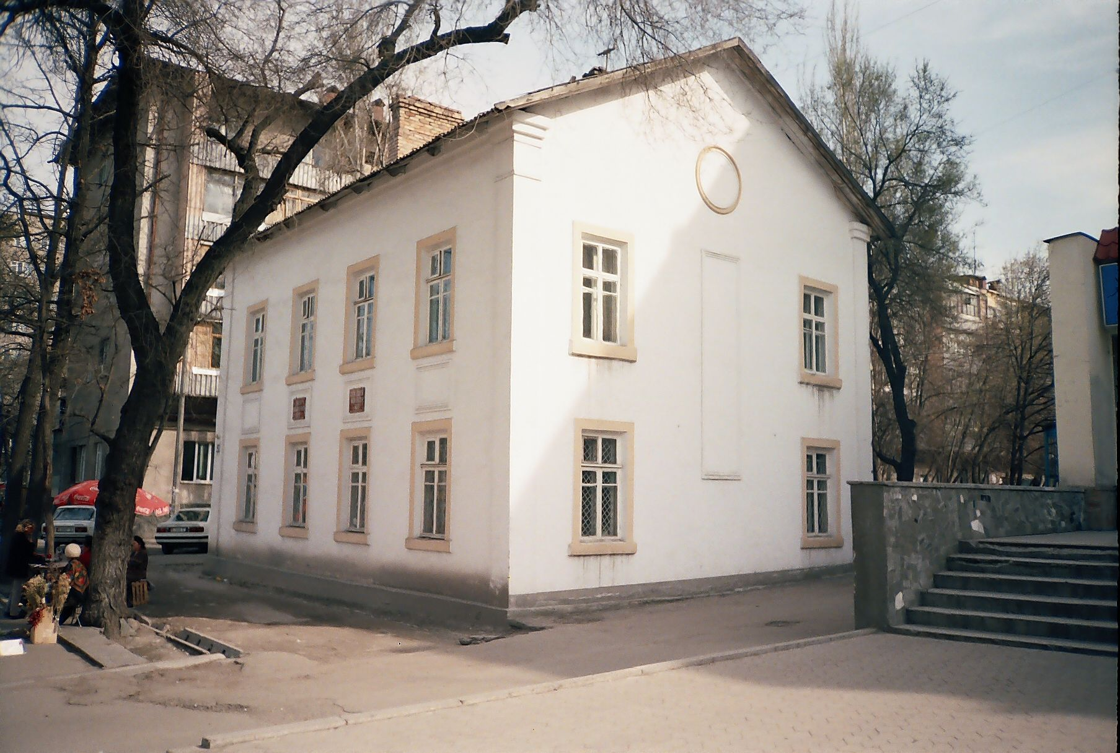
Первомайская адвокатура · Никиты Часова
ENGLISH Pervomaiskaya Bar
﻿ Pervomaiskaya Bar Administrative building from the 60s. Pervomayskaya Bar. Photo by Nikita Chasov.
Source: https://bimap.su/description/frunze/166_Advokat.txt · BIMAP
Фотографии и материалы принадлежат их авторам; лицензия не указана

BISHKEK
No information has been found for this period yet
42.86907, 74.61053

Фотография пока не добавлена
ENGLISH
No information has been found for this period yet.

