PISHPEK
No information has been found for this period yet
42.87110, 74.57505

Фотография пока не добавлена
ENGLISH
No information has been found for this period yet.

FRUNZE
Monument to Begeldinov
42.87110, 74.57505
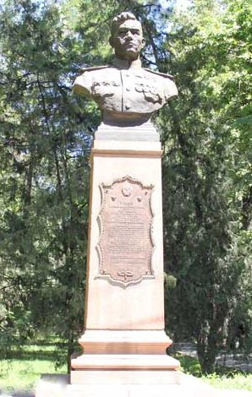
Памятник Бегельдинову
ENGLISH Monument to Begeldinov
﻿ Monument to Begeldinov Monument to Begeldinov, sculptor I.A.Abakumov, architect V.Veryuzhsky, 1948 Talgat Begeldinov (born in 1922). Twice Hero of the Soviet Union, attack pilot. The monument was originally erected on October 29, 1948 on the street. Stalin in front of the Central Election Commission building. In 1984, the monument was moved to Molodaya Gvardiya Boulevard.
Source: https://bimap.su/description/frunze/162_Begeldinov1.txt · BIMAP
Фотографии и материалы принадлежат их авторам; лицензия не указана

BISHKEK
No information has been found for this period yet
42.87110, 74.57505

Фотография пока не добавлена
ENGLISH
No information has been found for this period yet.

