PISHPEK
No information has been found for this period yet
42.87990, 74.58724

Фотография пока не добавлена
ENGLISH
No information has been found for this period yet.

FRUNZE
Panorama of the city
42.87990, 74.58724
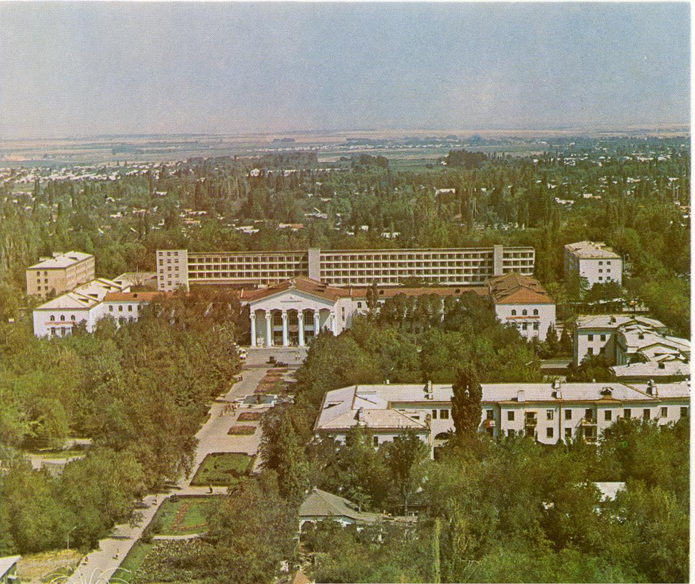
Панорама города · 1999 года
ENGLISH Panorama of the city
﻿ Panorama of the city Panorama of the city from a parachute tower, 60s. View to the south. In the foreground is the House of Unions and the XXII Party Congress (Chui) and Kyiv streets.
Source: https://bimap.su/description/frunze/160_Panorama99.txt · BIMAP
Фотографии и материалы принадлежат их авторам; лицензия не указана

BISHKEK
No information has been found for this period yet
42.87990, 74.58724

Фотография пока не добавлена
ENGLISH
No information has been found for this period yet.

