PISHPEK
No information has been found for this period yet
42.87717, 74.60685

Фотография пока не добавлена
ENGLISH
No information has been found for this period yet.

FRUNZE
Monument to F.E. Dzerzhinsky
42.87717, 74.60685
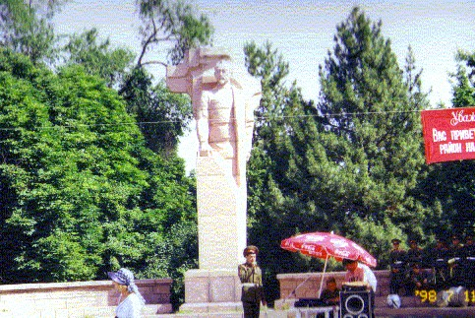
Памятник Ф.Э.Дзержинскому
ENGLISH Monument to F.E. Dzerzhinsky
﻿ Monument to F.E. Dzerzhinsky Monument to F.E. Dzerzhinsky (1877-1926). Founder of the Cheka (KGB). The author of the sculpture is T. Sadykov. Installed in 1987. Dismantled in 1999 and moved to the street. Tynystanova opposite the KGB building. In its place a monument to Freedom was erected - Erkindik.
Source: https://bimap.su/description/frunze/155_Dzerjinskii1.txt · BIMAP
Фотографии и материалы принадлежат их авторам; лицензия не указана

BISHKEK
No information has been found for this period yet
42.87717, 74.60685

Фотография пока не добавлена
ENGLISH
No information has been found for this period yet.

