PISHPEK
No information has been found for this period yet
42.87716, 74.60678

Фотография пока не добавлена
ENGLISH
No information has been found for this period yet.

FRUNZE
Monument to Lenin
42.87716, 74.60678
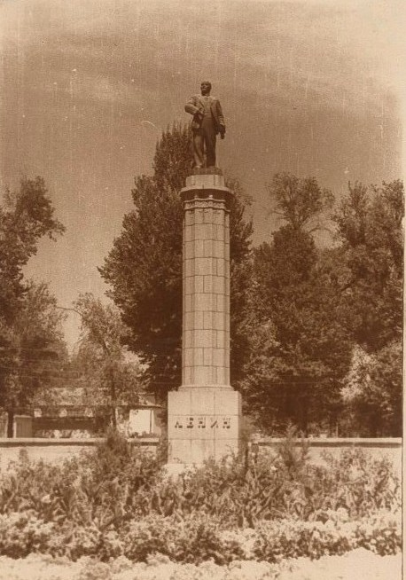
Памятник Ленину · Владимира Петрова
ENGLISH Monument to Lenin
﻿ Monument to Lenin Monument to Lenin. Sculptor G. Neroda, architect V. Veryuzhsky. 1948 Monument to Lenin. Sculptor G. Neroda, architect V. Veryuzhsky. 1948 Dismantled in 1984. A vase was installed in its place. In 1987, the vase was replaced by a monument to Felix Dzerzhinsky.
Source: https://bimap.su/description/frunze/154_Lenin1.txt · BIMAP
Фотографии и материалы принадлежат их авторам; лицензия не указана

BISHKEK
Architectural and sculptural composition dedicated to Kurmanjan Datka
42.87716, 74.60678
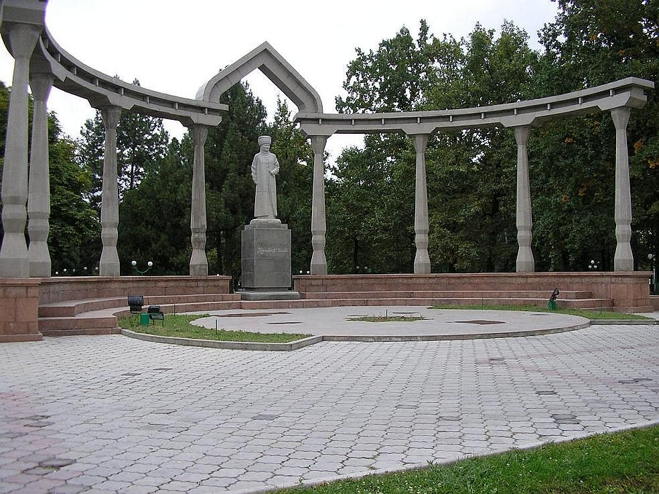
Архитектурно-скульптурная композиция, посвященная Курманджан Датке
ENGLISH Architectural and sculptural composition dedicated to Kurmanjan Datka
In 2004 at the intersection of Blvd. Erkindik and st. Pushkin, on the site of the monument to V.I. Lenin (F.E. Dzerzhinsky), an architectural and sculptural composition dedicated to Kurmanjan Datka (sculptor V. Shestopal, architect R. Muksinov) was placed.
Source: https://bimap.su/description/bishkek/10_rurmanjan.txt · BIMAP
Фотографии и материалы принадлежат их авторам; лицензия не указана

