PISHPEK
No information has been found for this period yet
42.87497, 74.57544

Фотография пока не добавлена
ENGLISH
No information has been found for this period yet.

FRUNZE
Young Guard Street
42.87497, 74.57544
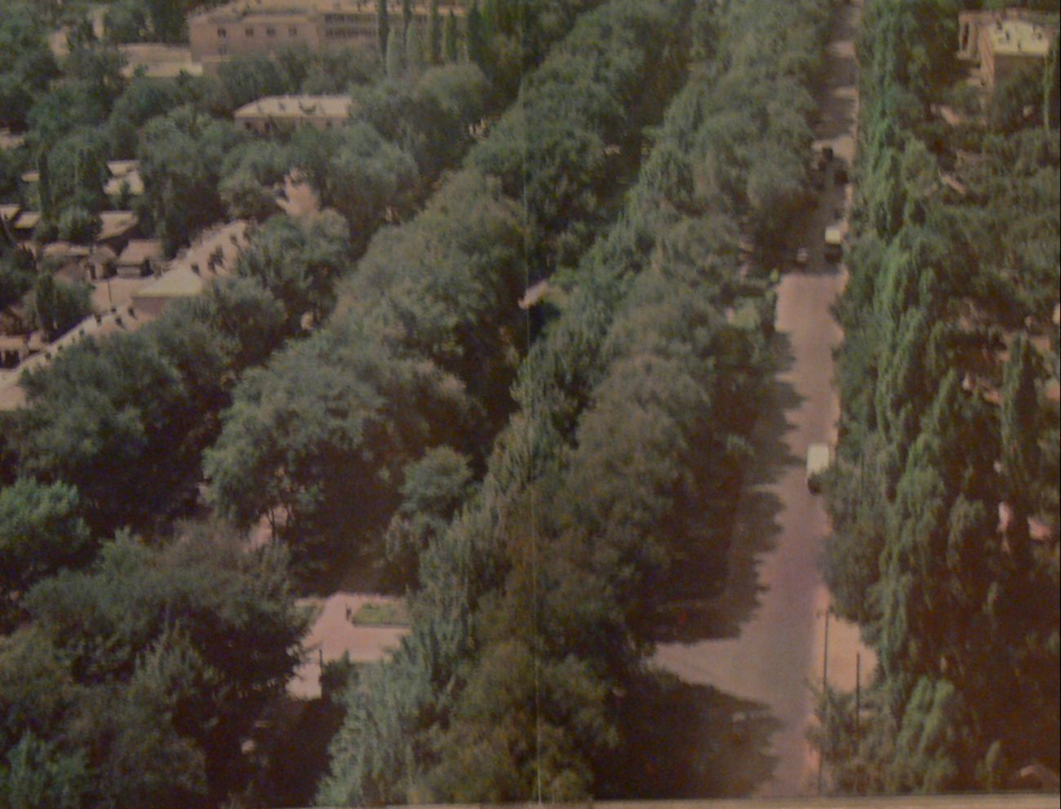
Улица Молодая гвардия · 1970 года
ENGLISH Young Guard Street
﻿ Young Guard Young Guard. Photo from 1970. The boulevard on Atbashinskaya Street was founded by landscaping work that began in March 1940. In 1948, it was given the name Young Guard. The length is 3 km from the railway line to the northern border of the city.
Source: https://bimap.su/description/frunze/149_Gvardia.txt · BIMAP
Фотографии и материалы принадлежат их авторам; лицензия не указана

BISHKEK
No information has been found for this period yet
42.87497, 74.57544

Фотография пока не добавлена
ENGLISH
No information has been found for this period yet.

