PISHPEK
No information has been found for this period yet
42.86746, 74.59811

Фотография пока не добавлена
ENGLISH
No information has been found for this period yet.

FRUNZE
Medical School
42.86746, 74.59811
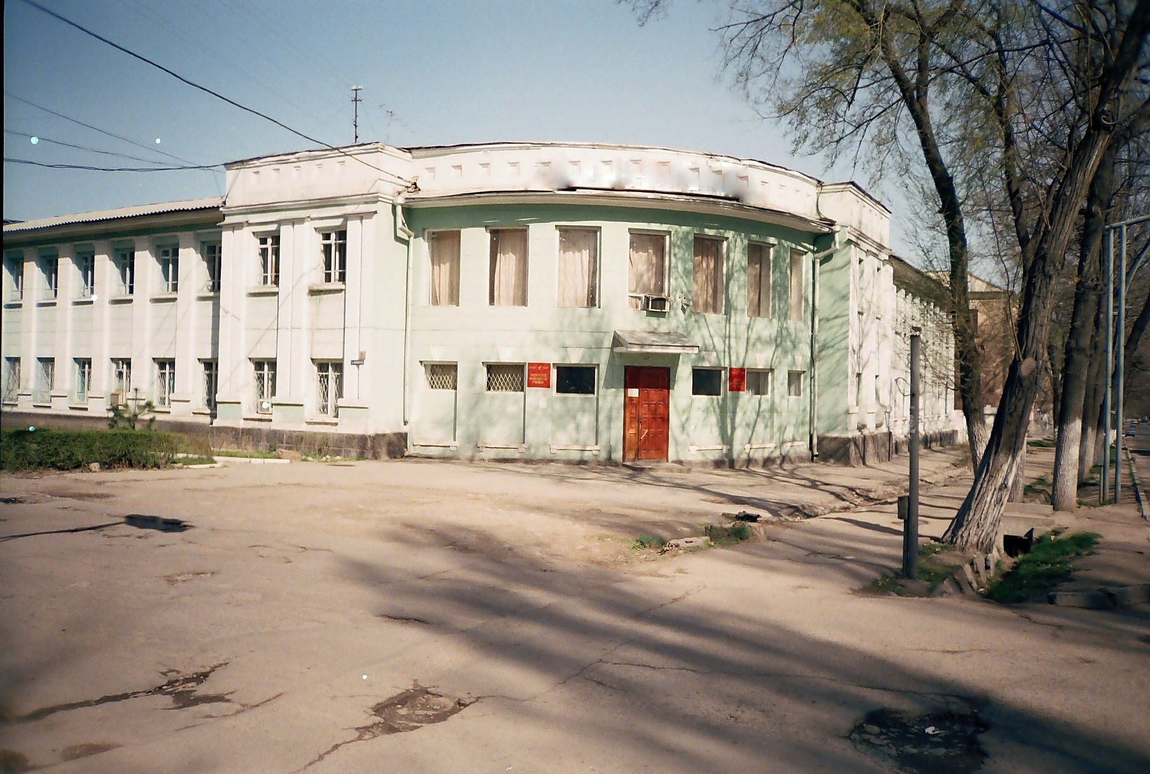
Медицинское училище
ENGLISH Medical School
﻿ Medical School Medical School. The building was built in 1935 as a medical school.
Source: https://bimap.su/description/frunze/146_Medshkola.txt · BIMAP
Фотографии и материалы принадлежат их авторам; лицензия не указана

BISHKEK
No information has been found for this period yet
42.86746, 74.59811

Фотография пока не добавлена
ENGLISH
No information has been found for this period yet.

