PISHPEK
No information has been found for this period yet
42.87672, 74.59089

Фотография пока не добавлена
ENGLISH
No information has been found for this period yet.

FRUNZE
Shop "Beryozka"
42.87672, 74.59089
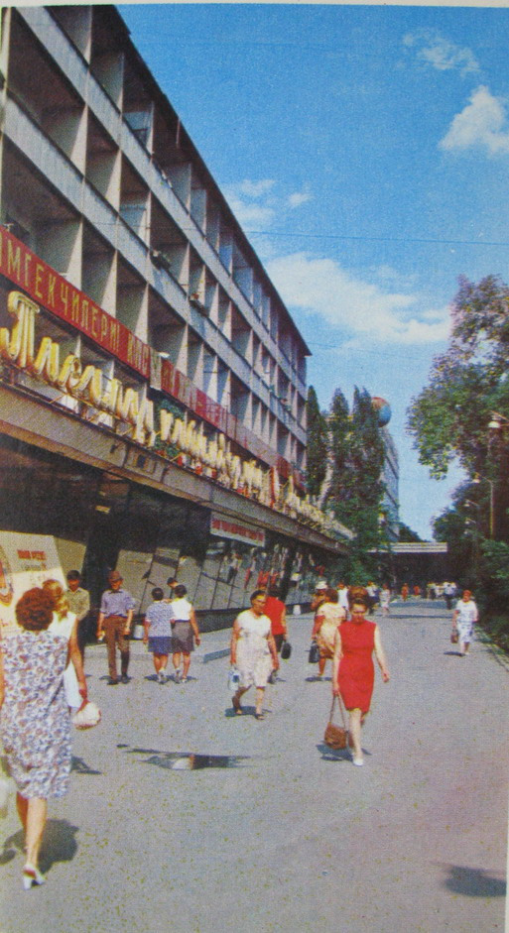
Магазин «Березка»
ENGLISH Shop "Beryozka"
﻿ Shop Berezka Shop Berezka at the XXII Party Congress. Berezka store in the building at the XXII Party Congress. Architect M. Pisarskaya, 1966 In Berezka stores they traded goods for foreign currency.
Source: https://bimap.su/description/frunze/144_Berezka.txt · BIMAP
Фотографии и материалы принадлежат их авторам; лицензия не указана

BISHKEK
No information has been found for this period yet
42.87672, 74.59089

Фотография пока не добавлена
ENGLISH
No information has been found for this period yet.

