PISHPEK
Men's parish school
42.87096, 74.60691
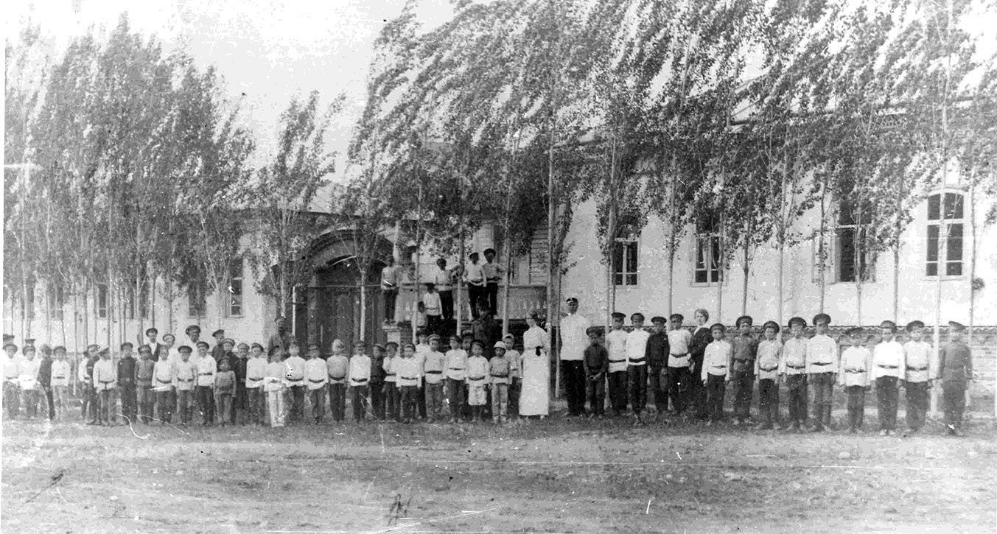
Мужское приходское училище
ENGLISH Men's parish school
﻿ Men's parish school on Boulevard 1915. Parish schools had the goal of preparing students for district schools, and they were also tasked with the physical and moral development of children. Subjects of study in parish schools: reading, writing, arithmetic, the Law of God, moral teaching, basic home economics. Financing of parish schools was carried out at the expense of the local population: in cities - at the expense of urban societies. Paroch
Source: https://bimap.su/description/pishpek/35_Prihodskoe_uchilische.txt · BIMAP
Фотографии и материалы принадлежат их авторам; лицензия не указана

FRUNZE
No information has been found for this period yet
42.87096, 74.60691

Фотография пока не добавлена
ENGLISH
No information has been found for this period yet.

BISHKEK
No information has been found for this period yet
42.87096, 74.60691

Фотография пока не добавлена
ENGLISH
No information has been found for this period yet.

