PISHPEK
No information has been found for this period yet
42.86280, 74.59692

Фотография пока не добавлена
ENGLISH
No information has been found for this period yet.

FRUNZE
Lev Tolstoy Street
42.86280, 74.59692
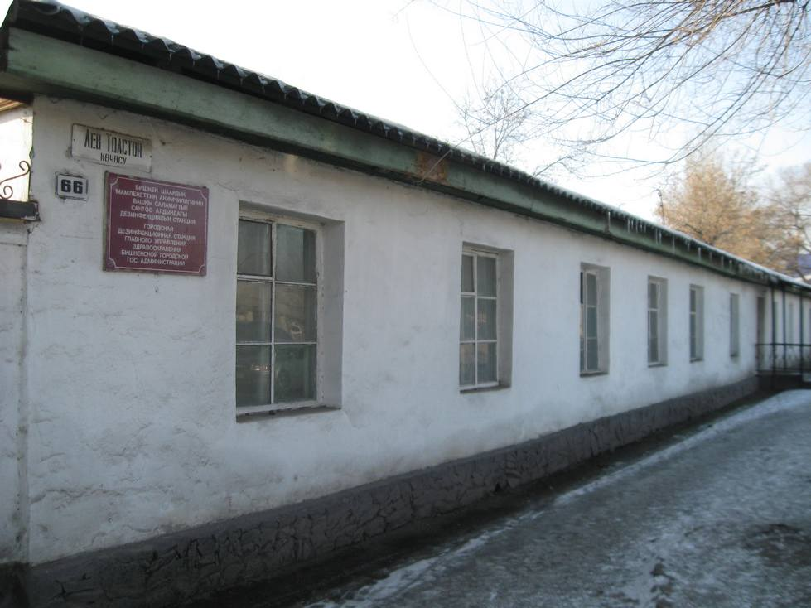
Улица Льва Толстого
ENGLISH Lev Tolstoy Street
﻿ Barracks on Lev Tolstoy Street Residential barracks for aircraft repair shops.
Source: https://bimap.su/description/frunze/143_Tolstogo.txt · BIMAP
Фотографии и материалы принадлежат их авторам; лицензия не указана

BISHKEK
No information has been found for this period yet
42.86280, 74.59692

Фотография пока не добавлена
ENGLISH
No information has been found for this period yet.

