PISHPEK
No information has been found for this period yet
42.87644, 74.58516

Фотография пока не добавлена
ENGLISH
No information has been found for this period yet.

FRUNZE
Puppet theater
42.87644, 74.58516
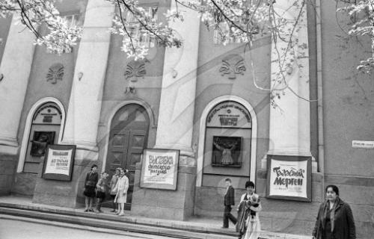
Кукольный театр
ENGLISH Puppet theater
﻿ Puppet theater The puppet theater did not have its own building and was located either in the mosque building or in the Lux store. In the 80s it was located in the building of the Ministry of Agriculture.
Source: https://bimap.su/description/frunze/138_Kukolnyi.txt · BIMAP
Фотографии и материалы принадлежат их авторам; лицензия не указана

BISHKEK
No information has been found for this period yet
42.87644, 74.58516

Фотография пока не добавлена
ENGLISH
No information has been found for this period yet.

