PISHPEK
Women's pro-gymnasium
42.88518, 74.61253
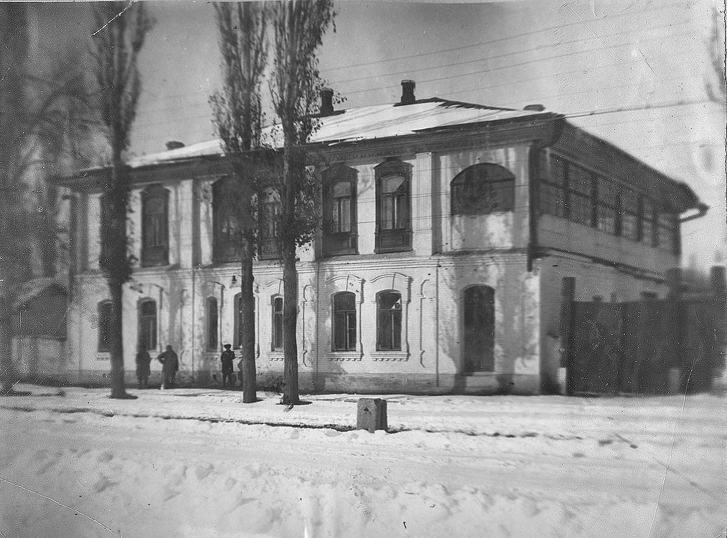
Женская прогимназия
ENGLISH Women's pro-gymnasium
﻿ Women's pro-gymnasium 1916 In 1916, a private school for girls owned by V.I. Voronkevich was transformed into a women's pro-gymnasium. The two-story building was located on Tashkentskaya, where the Chinese store “Goin” is located today. In the first years of Soviet power, the building housed the revolutionary committee and the regional party committee of the Kara-Kyrgyz Autonomous Region, the city committee of the Komsomol.
Source: https://bimap.su/description/pishpek/34_Progimnazia.txt · BIMAP
Фотографии и материалы принадлежат их авторам; лицензия не указана

FRUNZE
No information has been found for this period yet
42.88518, 74.61253

Фотография пока не добавлена
ENGLISH
No information has been found for this period yet.

BISHKEK
Goin Store
42.88518, 74.61253
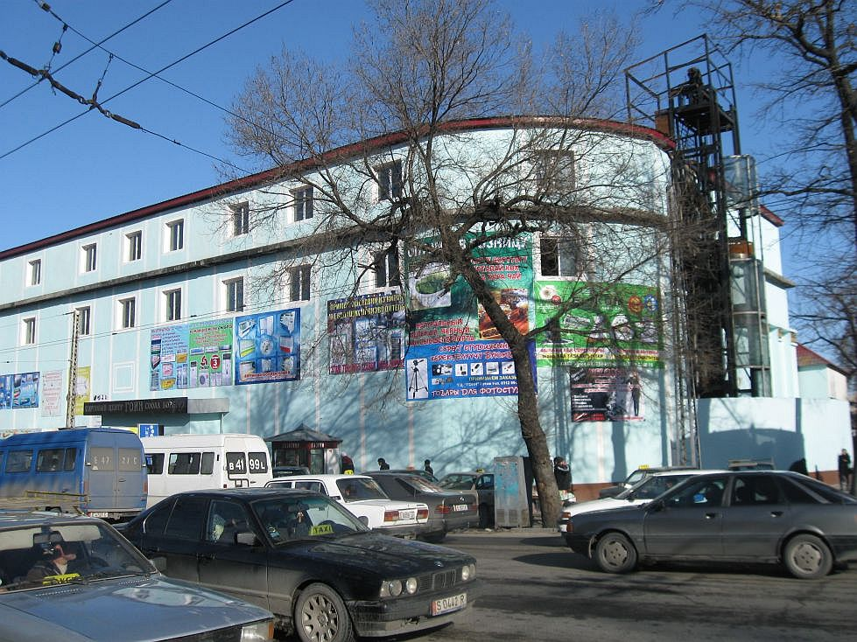
Магазин Гоин · Владимира Петрова
ENGLISH Goin Store
Goin Store. Photo by Vladimir Petrov.
Source: https://bimap.su/description/bishkek/20_goin.txt · BIMAP
Фотографии и материалы принадлежат их авторам; лицензия не указана

