PISHPEK
No information has been found for this period yet
42.87825, 74.60721

Фотография пока не добавлена
ENGLISH
No information has been found for this period yet.

FRUNZE
Cinema "Udarnik"
42.87825, 74.60721
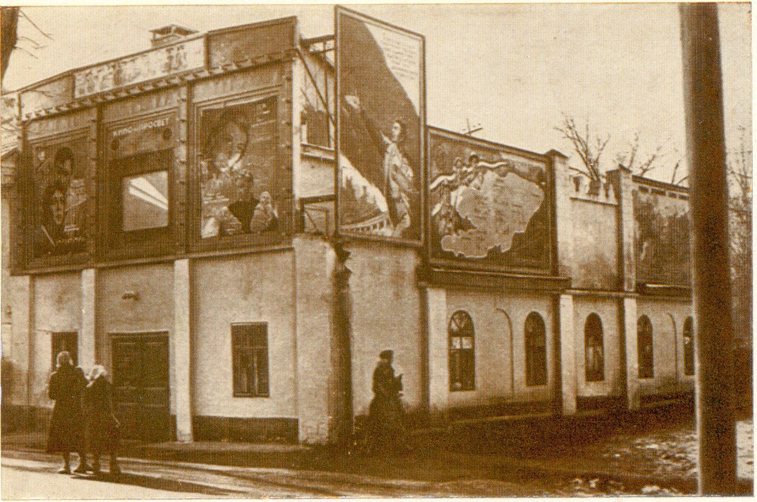
Кинотеатр «Ударник»
ENGLISH Cinema "Udarnik"
﻿ Cinema "Udarnik" Cinema "Udarnik". The summer cinema was built in 1930. Later, a roof was built over it, the name Udarnik was given, and for a long time it was the most spacious cinema in the city. The building was not heated, it had no ceiling, and sparrows and bats nested in the rafters. However, this giant barn was never empty. “Merry Fellows”, Disney’s “Snow White”, “War and Peace” were shown here. Sergei Bondarchuk. In the 40s, young Isaac
Source: https://bimap.su/description/frunze/133_Udarnik.txt · BIMAP
Фотографии и материалы принадлежат их авторам; лицензия не указана

BISHKEK
No information has been found for this period yet
42.87825, 74.60721

Фотография пока не добавлена
ENGLISH
No information has been found for this period yet.

