PISHPEK
No information has been found for this period yet
42.87489, 74.59252

Фотография пока не добавлена
ENGLISH
No information has been found for this period yet.

FRUNZE
School
42.87489, 74.59252
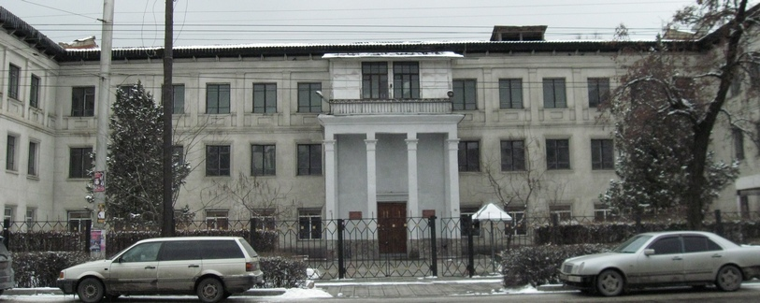
Школа · Владимира Петрова
ENGLISH School
﻿ School. Photo by Vladimir Petrov, 2011. Aircraft-monument to military glory. Established in 1975. The first three-story school building in the city, built in the 40s. During the 2nd World War, the building of the former school No. 15 housed the 2nd battalion of the Frunze Infantry School. In the 60s, the Faculty of Law and the Military Department of KSU.
Source: https://bimap.su/description/frunze/129_Shkola15.txt · BIMAP
Фотографии и материалы принадлежат их авторам; лицензия не указана

BISHKEK
No information has been found for this period yet
42.87489, 74.59252

Фотография пока не добавлена
ENGLISH
No information has been found for this period yet.

