PISHPEK
No information has been found for this period yet
42.87296, 74.59618

Фотография пока не добавлена
ENGLISH
No information has been found for this period yet.

FRUNZE
Military town
42.87296, 74.59618
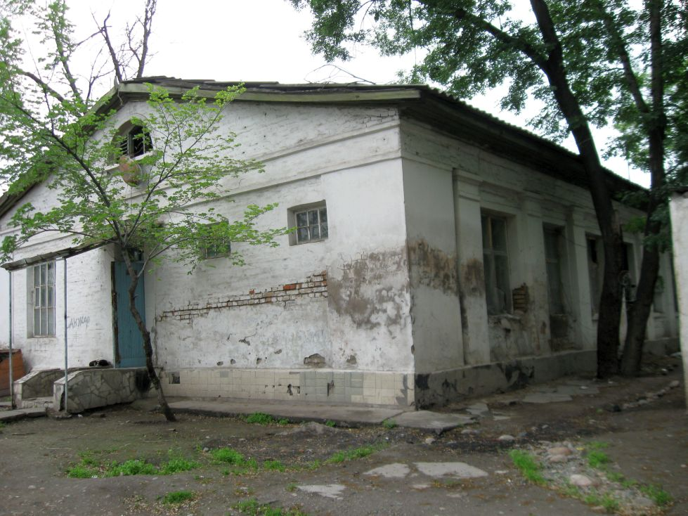
Военный городок · Владимира Петрова
ENGLISH Military town
﻿ Military town. Photo by Vladimir Petrov, 2011. Military barracks, 40s. The oldest wooden, stone and adobe buildings in the city. Initially, Togolok Moldo street was called Kazarmennaya, Logvinenko street - Bolnichnaya, Bokonbaev street - Lagernaya, because almost along its entire length from Frunze-Sudeiskaya street to the southern outskirts this territory of the city was occupied by military buildings - barracks, an infirmary, military squares
Source: https://bimap.su/description/frunze/127_Kazarmy.txt · BIMAP
Фотографии и материалы принадлежат их авторам; лицензия не указана

BISHKEK
No information has been found for this period yet
42.87296, 74.59618

Фотография пока не добавлена
ENGLISH
No information has been found for this period yet.

