PISHPEK
No information has been found for this period yet
42.87368, 74.59781

Фотография пока не добавлена
ENGLISH
No information has been found for this period yet.

FRUNZE
Military town
42.87368, 74.59781
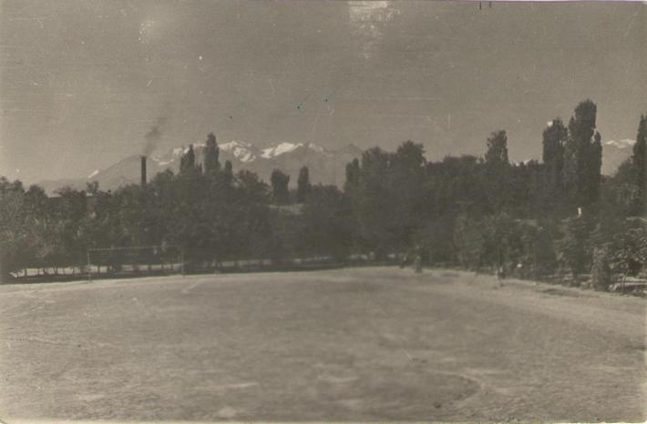
Военный городок · Виктора Трусова
ENGLISH Military town
﻿ Military town. Photo by Viktor Trusov The main parade ground of the military town. Initially, Togolok Moldo street was called Kazarmennaya, Logvinenko street - Bolnichnaya, Bokonbaev street - Lagernaya, because almost along its entire length from Frunze-Sudeiskaya street to the southern outskirts this territory of the city was occupied by military buildings - barracks, an infirmary, military squares, training grounds and camps. During World War
Source: https://bimap.su/description/frunze/124_Plats.txt · BIMAP
Фотографии и материалы принадлежат их авторам; лицензия не указана

BISHKEK
No information has been found for this period yet
42.87368, 74.59781

Фотография пока не добавлена
ENGLISH
No information has been found for this period yet.

