PISHPEK
No information has been found for this period yet
42.87103, 74.60554

Фотография пока не добавлена
ENGLISH
No information has been found for this period yet.

FRUNZE
Institute of Geology
42.87103, 74.60554
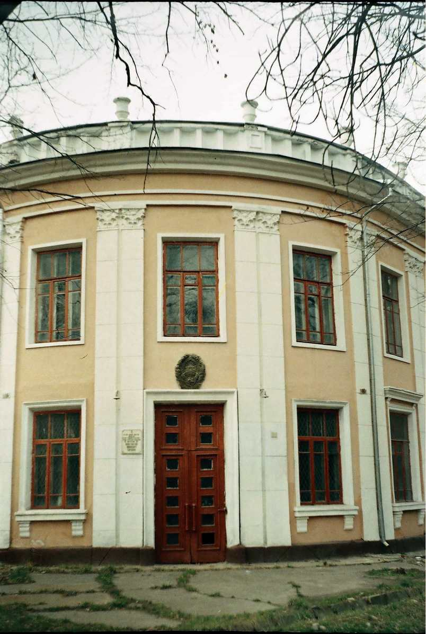
Институт геологии · Владимира Петрова
ENGLISH Institute of Geology
﻿ Institute of Geology. Photo by Vladimir Petrov, 2003. Institute of Geology of the Academy of Sciences of the Kirghiz SSR, 1990, photo by Vladimir Petrov. The building is located on Dzerzhinsky Avenue (architect P.P. Ivanov). The building was built as a pedagogical college and was completed in 1941. But classes for students have never been held here. With the beginning of the Great Patriotic War, it housed a military hospital and the biological
Source: https://bimap.su/description/frunze/120_Institut_geologii.txt · BIMAP
Фотографии и материалы принадлежат их авторам; лицензия не указана

BISHKEK
No information has been found for this period yet
42.87103, 74.60554

Фотография пока не добавлена
ENGLISH
No information has been found for this period yet.

