PISHPEK
No information has been found for this period yet
42.86817, 74.59831

Фотография пока не добавлена
ENGLISH
No information has been found for this period yet.

FRUNZE
Dental School
42.86817, 74.59831
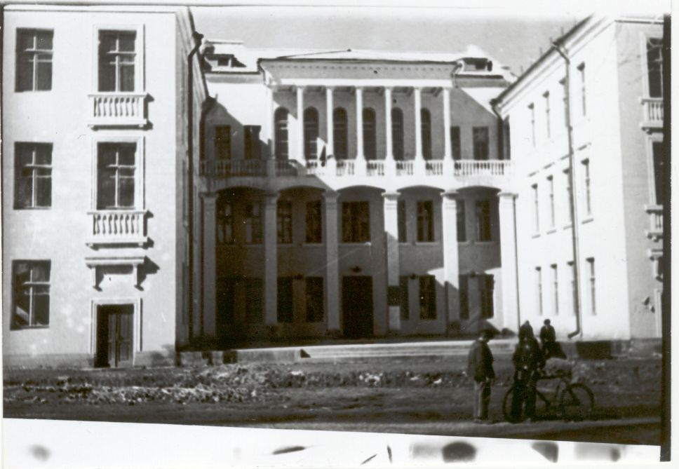
Зубоврачебная школа
ENGLISH Dental School
﻿ Dental School. Architect G.Kh.Sahakyan, 1940 During the war, the Institute of Biochemistry and Plant Physiology of the USSR Academy of Sciences, evacuated from Moscow, headed by A.N. Bach and V.A. Engelhard, worked in this building during the war. On the facade of the building there is a memorial plaque to Professor Boris Fedorovich Malyshev, the founder of the Department of Pathological Anatomy of the Medical Institute.
Source: https://bimap.su/description/frunze/118_Zubovrachebnaia_shkola.txt · BIMAP
Фотографии и материалы принадлежат их авторам; лицензия не указана

BISHKEK
No information has been found for this period yet
42.86817, 74.59831

Фотография пока не добавлена
ENGLISH
No information has been found for this period yet.

