PISHPEK
No information has been found for this period yet
42.87678, 74.60904

Фотография пока не добавлена
ENGLISH
No information has been found for this period yet.

FRUNZE
ChuTrest building
42.87678, 74.60904
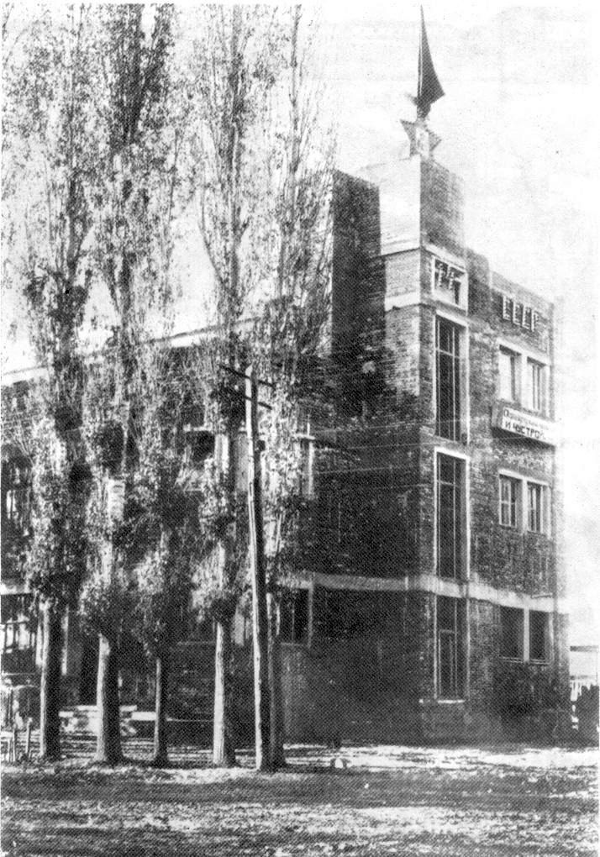
Здание «ЧуТреста»
ENGLISH ChuTrest building
﻿ ChuTrust building Chustroy building (architect P. Goncharov, 1932). During the Great Patriotic War, the Krichev Rifle Division was formed in it, which fought from Moscow to the banks of the Elbe in Germany. For many years, the editorial offices of the newspapers “Soviet Kyrgyzstan” and “Kyzyl Kyrgyzstan” worked here, and then the republican society “Knowledge”.
Source: https://bimap.su/description/frunze/116_Cnutrest.txt · BIMAP
Фотографии и материалы принадлежат их авторам; лицензия не указана

BISHKEK
No information has been found for this period yet
42.87678, 74.60904

Фотография пока не добавлена
ENGLISH
No information has been found for this period yet.

