PISHPEK
No information has been found for this period yet
42.84285, 74.61484

Фотография пока не добавлена
ENGLISH
No information has been found for this period yet.

FRUNZE
Institute of Physical Education
42.84285, 74.61484
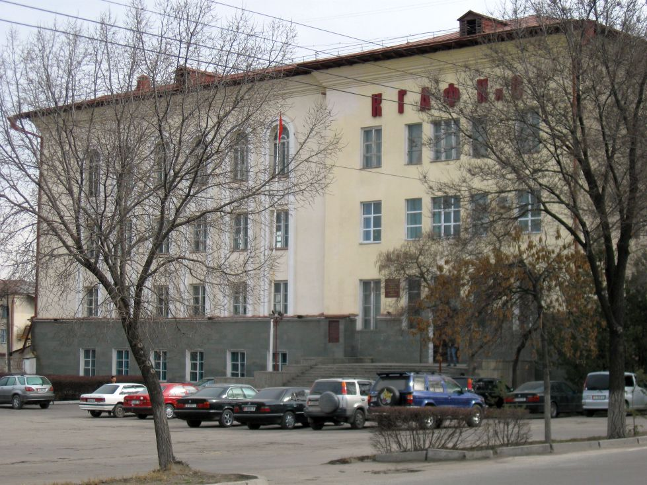
Институт физкультуры · Владимира Петрова
ENGLISH Institute of Physical Education
﻿ Institute of Physical Education. The building was built in 1964. Photo by Vladimir Petrov Founded in 1955 on the basis of the physical education department of KSU.
Source: https://bimap.su/description/frunze/114KGIFK.txt · BIMAP
Фотографии и материалы принадлежат их авторам; лицензия не указана

BISHKEK
No information has been found for this period yet
42.84285, 74.61484

Фотография пока не добавлена
ENGLISH
No information has been found for this period yet.

