PISHPEK
Pishpek men's gymnasium
42.88390, 74.60546
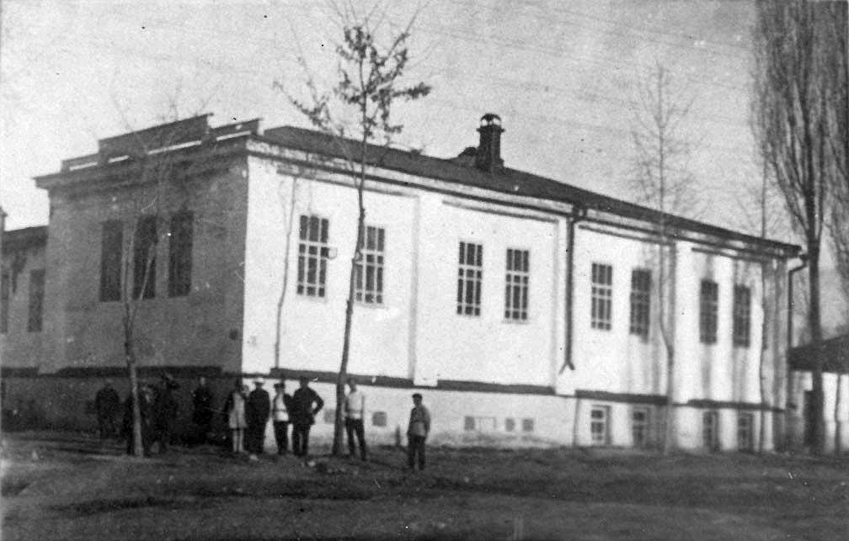
Пишпекская мужская гимназия
ENGLISH Pishpek men's gymnasium
﻿ Pishpek men's gymnasium, on the south-eastern corner of Vasilyevskaya and Tashkentskaya streets In 1912, a men's gymnasium was opened on the basis of a Russian-native boarding school (Vasilievskaya-Tashkentskaya). In the summer, director Andrei Vasilyevich Jungmeister arrived from Odessa. With him came clerk Prokopiy Avtonomovich Dyachenko, preparatory class teacher Vasily Ivanovich Voronkevich, mathematicians Viktor Vasilyevich Matkovsky, and
Source: https://bimap.su/description/pishpek/32_Gimnazia.txt · BIMAP
Фотографии и материалы принадлежат их авторам; лицензия не указана

FRUNZE
School No. 4
42.88390, 74.60546
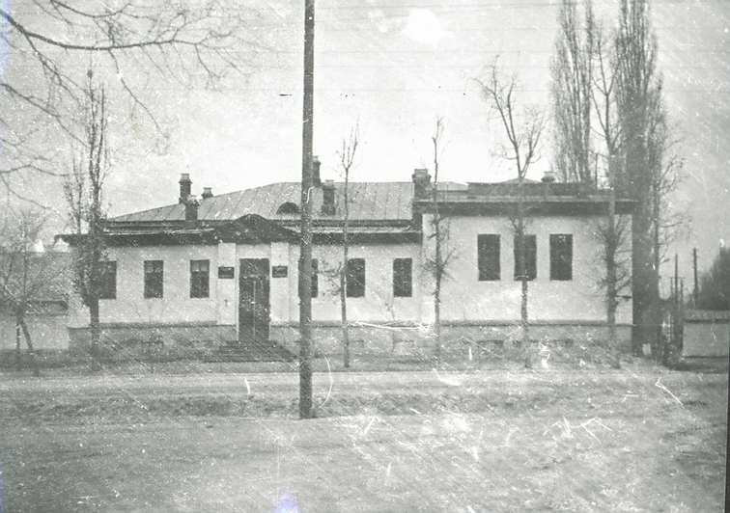
Школа №4
ENGLISH School No. 4
﻿ School No. 4, 1930s In 1927-28, 15 schools operated in Frunze. 7th year school No. 4. It was located in the building of the former Pishpek men's gymnasium on Lenin Street.
Source: https://bimap.su/description/frunze/199_Shkola_30g.txt · BIMAP
Фотографии и материалы принадлежат их авторам; лицензия не указана

BISHKEK
No information has been found for this period yet
42.88390, 74.60546

Фотография пока не добавлена
ENGLISH
No information has been found for this period yet.

