PISHPEK
No information has been found for this period yet
42.84220, 74.61369

Фотография пока не добавлена
ENGLISH
No information has been found for this period yet.

FRUNZE
Institute of Oncology
42.84220, 74.61369
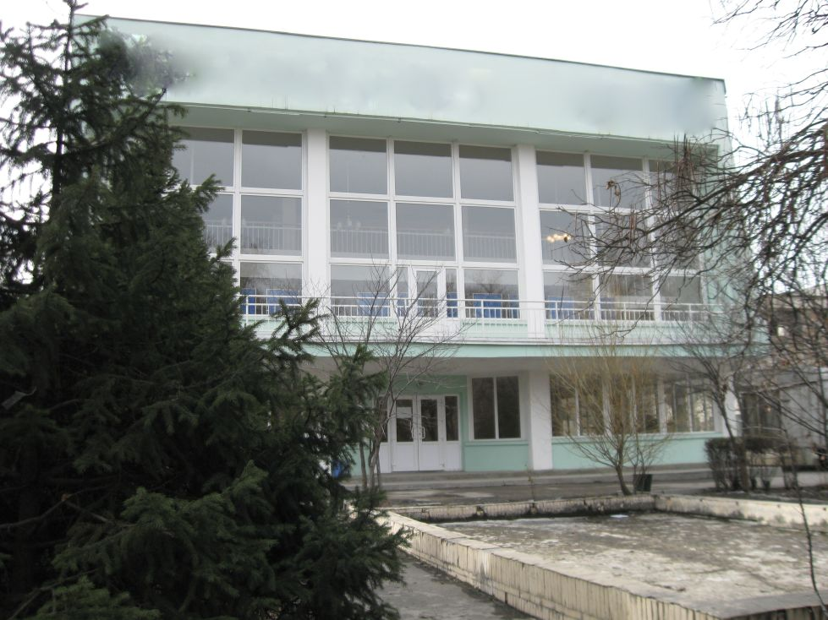
Институт онкологии · Владимира Петрова
ENGLISH Institute of Oncology
﻿ Institute of Oncology. Photo by Vladimir Petrov The Kyrgyz Research Institute of Oncology and Radiology was created in 1959. It is a major scientific and medical center of Kyrgyzstan. The activities of the institute are associated with the names of A.I. Saenko and A. Ilyazov.
Source: https://bimap.su/description/frunze/113_Onkologia.txt · BIMAP
Фотографии и материалы принадлежат их авторам; лицензия не указана

BISHKEK
No information has been found for this period yet
42.84220, 74.61369

Фотография пока не добавлена
ENGLISH
No information has been found for this period yet.

